Germany needs to prioritise growth
Key messages
- As Germany heads to the polls for a snap election in February 2025, voters are faced with an economy stuck in a rut. The economy lost growth momentum before the onset of the pandemic and has been essentially flat for five years. Without fiscal intervention and reforms Germany, be headed for a lost decade.
- Conjuncturally, there is a strong case for fiscal Keynesian-style stimulus: household consumption is below its 2019 level, whilst the savings rate of German households and corporates seems to be ticking up again, leaving the government as the ‘spender of last resort’. German exports are declining faster than imports, further underlining the weakness of domestic demand.
- More importantly, the economy is held back by several overlapping and structural trends that require a sustained public investment push and supply-side reforms.
  - High energy prices following the cutoff from Russian gas;
  - China has gone from consumer to competitor. German exports to China have declined by 0.5% of German GDP already and there is much more room for decline. China’s exploding exports elsewhere cut off avenues for Germany to export its way out of its stagnation;
  - After two decades of belt-tightening, and a public investment ratio languishing at the bottom of the EU and OECD tables, German infrastructure and human capital formation need an urgent boost to foster a reallocation of labour and capital.
- The centrist political parties, alongside the German council of economic exports and the Bundesbank, have endorsed a reform of the constitutional debt brake, that limits net debt issuance at 0.35% of German GDP, for public investment and military expenditure. But the precise shape of the reform is up for debate still.
- Once the debt brake is reformed, there is ample room to run a looser fiscal policy under the Stability and Growth Pact,. The SGP introduces a "deficit safeguard" that permits structural deficits up to 1.5% of GDP, far exceeding the 0.35% cap imposed by the Schuldenbremse.
- A reform of the debt brake may disappoint. The lowest common denominator is a targeted reform focused on military spending, which would help to rebuild the country’s military stock but do little to lift the rest of the economy out of stagnation.

Germany’s economic and fiscal situation
Germany faces mounting challenges as it navigates a period of economic stagnation and industrial decline. These challenges are compounded by the structural constraints of its fiscal policies and increasing competition from China. This briefing explores the roots of these issues, highlights emerging opportunities, and outlines policy recommendations to ensure Germany’s economic resilience and leadership within Europe.

Source: CER analysis of Eurostat
Germany’s industrial production has been in decline for over five years, exacerbating fears of deindustrialisation. Manufacturing accounts for around 20% of GDP and 5.5 million jobs, making this decline existential for the economy. While Germany’s export-driven model historically thrived, the dynamics have shifted. During the 2010s, Germany’s industrial strength was underpinned by high demand for its exports, particularly in chemicals, machinery, and cars – which still make up 40% of the country’s exports (about 15% of German GDP). The country’s surpluses were bolstered by a policy of restrained wages and tight budgets, which kept its products competitive globally. However, this model relied heavily on external demand, notably from China and the US.
After the 2008 financial crisis, China’s massive fiscal stimulus absorbed German exports, particularly in industrial sectors aligned with China’s infrastructure boom. Germany outsourced much of the spending needed for recovery to Chinese and American fiscal policies. Yet this reliance on external demand created vulnerabilities. China’s recent shift back to export-led growth, coupled with its industrial subsidies and innovation, has intensified competition. China’s growing dominance in global manufacturing is now a direct threat to Germany’s industrial base, particularly in automotive and engineering.
The scale of the current “China shock” dwarfs that of the early 2000s. When China joined the World Trade Organization (WTO) in 2001, its exports surged, but they were largely concentrated in consumer electronics and household goods—areas peripheral to Germany’s industrial core. Today, China’s trade surplus in manufactured goods stands at 10% of its GDP. The Chinese economy, valued at $18 trillion and accounting for over a third of global manufacturing, is now cutting into Germany’s export opportunities. China has also become the world’s largest car exporter, with vehicle exports soaring to over six million annually within just four years. Unlike the 2000s, Germany’s key sectors now face direct competition from Chinese state-backed firms in saturated markets.

Source: Sander Tordoir und Brad Setser, Centre for European Reform Policy Brief: "The Second China Shock and the Future of German Industry" (forthcoming).
Domestic demand, meanwhile, has been weak. As of the second quarter of 2024, German households had a gross saving rate of approximately 21.23% of their disposable income, significantly higher than the eurozone average of 15.7%. German households are saving into a year-long stagnation. According to Bloomberg economics research, high energy costs and slumping exports have made German households €2,500 poorer and the decline threatens to become irreversible.
Germany's public investment ratio has consistently lagged both OECD and EU averages over the past two decades. From 2000 to 2022, Germany's average public investment ratio was 2.2% of GDP, compared to the EU average of 3.2% of GDP. Germany's public investment has been the second lowest in the OECD at 1.5% of GDP, with net public investment being negative since 2003. This persistent underinvestment in public infrastructure compared to European and OECD peers has raised concerns about its long-term impact on Germany's growth prospects and competitiveness.
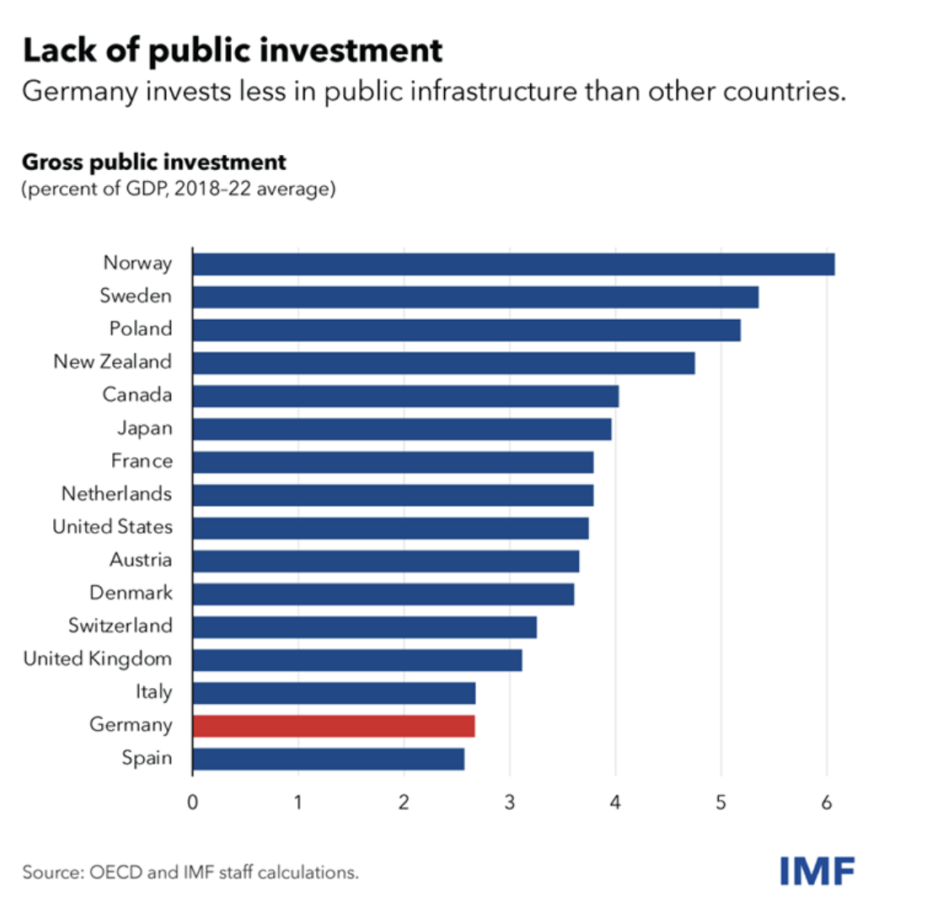
Source: IMF Blog.
Germany’s fiscal framework, particularly the "Schuldenbremse" (debt brake), has compounded these challenges. Introduced in 2009 to enforce fiscal discipline, the debt brake limits structural annual deficits to 0.35% of GDP. While it stabilised public debt, it also entrenched underinvestment in critical areas such as infrastructure, digitalisation, and education. Net spending on higher education, for instance, grew by less than 1% in inflation-adjusted terms between 2010 and 2018, compared to 6% in the Netherlands and 15% in the US. Germany’s public investment gap is now estimated at €600 billion, or roughly 15% of GDP. Addressing NATO’s 2% defence spending target alone requires an additional €30 billion annually.
Recent analyses challenge the perception that the EU’s fiscal rules are overly restrictive. While Germany has yet to submit a fiscal-structural plan, studies indicate that the EU’s updated Stability and Growth Pact provides significantly more flexibility than the national debt brake. Specifically, Germany could access up to 1.15% of GDP annually in additional structural borrowing—approximately €48 billion—without breaching EU rules. This flexibility hinges on using debt to finance growth-enhancing investments, such as infrastructure upgrades, digitalisation, and education. Notably, the rules emphasise the importance of coupling borrowing with structural reforms to improve growth potential. These provisions refute claims that EU rules are more restrictive than the Schuldenbremse and underscore the need for a comprehensive reform of Germany’s fiscal framework.
Germany’s fiscal outlook demonstrates significant shifts in the coming years. According to IMF projections, Germany’s fiscal deficit is expected to shrink from 2.4% of GDP in 2023 to 1.7% in 2024, driven by the phase-out of temporary energy relief measures and tight fiscal policies. By 2025, the deficit is forecasted to narrow further to 1.3% of GDP. Public debt, currently at 63.6% of GDP, is projected to stabilise and then decline to below 60% by 2028, as nominal GDP growth and tighter fiscal policies improve debt dynamics. However, the tight adherence to the debt brake rule, requiring structural deficits to remain below 0.35% of GDP, leaves limited room for maneuver unless reforms are implemented.
To contextualize this trajectory, it is critical to examine Germany’s fiscal performance in comparison to its European peers. France, for instance, has consistently maintained a higher debt-to-GDP ratio, currently exceeding 110%, while adopting looser fiscal policies to support domestic demand. Meanwhile, Germany’s conservative fiscal stance has curbed internal consumption and public investment, compounding the stagnation of its economy. This disparity highlights the tension between Germany’s commitment to fiscal discipline and the broader need for growth-oriented policies in the EU. Without recalibrating its approach, Germany risks undermining not only its own economic prospects but also the stability of the European single market.
The updated Stability and Growth Pact introduces a multi-year expenditure path monitored through a fiscal-structural plan submitted by member-states. This plan must detail how expenditure aligns with debt sustainability and investment needs. Unlike the Schuldenbremse, which rigidly limits structural deficits, the EU framework incorporates flexibility for investments that enhance growth potential, particularly in member-states with debt levels below 60% of GDP. Germany, with a debt level hovering around 63% and projected to decline further, is well-positioned to benefit from this framework. Furthermore, the Pact’s debt safeguard ensures gradual debt reduction over a four-to-seven-year adjustment period, allowing for higher nominal expenditures tied to reforms and productivity-enhancing investments. This provides Germany with the opportunity to reform its fiscal policies without undermining European commitments.
The Stability and Growth Pact also introduces a "deficit safeguard" that permits structural deficits up to 1.5% of GDP, far exceeding the 0.35% cap imposed by the Schuldenbremse. This translates into significant fiscal space—approximately €48 billion annually—for debt-financed investments in areas such as infrastructure, green technologies, and digitalisation. However, the effective use of this space depends on Germany’s ability to implement an ambitious reform agenda addressing its structural economic challenges. Without such reforms, the EU rules’ flexibility could be constrained, limiting their transformative potential.
The International Monetary Fund (IMF) has also weighed in on Germany’s fiscal policies, urging the government to make full use of the flexibility allowed under existing rules. The IMF highlighted the urgent need to increase public investment in areas like transport, energy, and digital infrastructure. These investments, the IMF argues, would not only address structural bottlenecks but also support long-term growth, productivity, and external rebalancing. Additionally, the IMF recommends reforms to the Schuldenbremse that would allow for a moderate easing of fiscal constraints without jeopardising debt sustainability. For instance, linking pension increases to inflation instead of wages and reducing environmentally harmful subsidies could generate significant fiscal room for investment. Such measures, paired with streamlined public procurement processes, could enhance Germany’s capacity to deploy funds efficiently and effectively.

Source: Sander Tordoir und Brad Setser, Centre for European Reform Policy Brief: "The Second China Shock and the Future of German Industry" (forthcoming).

Despite these challenges, Germany retains a comparative advantage in green industries, where it leads globally in low-carbon technology patents. Exports in 200 key green technologies account for 4% of GDP, outpacing all other G7 economies. The EU’s single market also continues to deliver growth, with intra-EU goods trade rising by over 30% since the pandemic. However, these advantages are under threat. China’s dominance in green technologies and its shrinking imports risk suppressing German firms’ profitability and innovation. Without sufficient profits to reinvest, these firms may fall behind the technological frontier.
Germany’s fiscal policy reform must also address broader macroeconomic vulnerabilities. Strategic trade measures are essential to counter China’s unfair trade practices and to strengthen Germany’s position in global markets. This includes advocating for WTO-compliant tariffs on subsidised Chinese exports, such as electric vehicles, while protecting viable EU sectors. Aligning with international partners, particularly within the EU, is crucial for mounting an effective response.
The potential for a unified EU industrial policy offers another avenue for addressing these challenges. The EU can rely on carbon taxes, regulation, and its own large domestic market. It does not need to replicate the expensive inflation reduction act, which is about 0.4% of US GDP a year. By earmarking tariff revenues from trade defence measures against China, the EU could fund a common industrial strategy. Such an approach would help avoid fragmented subsidy policies that disproportionately benefit larger economies like Germany. Moreover, integrating “buy-European” and environmental conditions into subsidy schemes could counter China’s local content requirements and foster a more competitive European industrial base.
The stakes are high. Germany’s low debt levels and strong industrial legacy provide a unique opportunity to act decisively. Yet this window is narrowing. To secure its economic future, Germany must prioritise domestic resilience and EU-wide coordination over short-term gains. Successfully navigating the China shock and revitalising its industrial base depend on addressing internal constraints, leveraging new fiscal flexibility, and fostering sustainable growth within the EU framework. The EU’s evolving fiscal rules could become a crucial ally in this effort, enabling Germany to align its fiscal and industrial strategies while maintaining its leadership within Europe. As Henry Kissinger once remarked, Germany is “too big for Europe and too small for the world.” Coordinated action within the EU is not just desirable but essential for securing Germany’s long-term economic resilience.

