**Contribution of ENCO to the Discussion on Future of the nuclear energy in the Netherlands**

The ENCO study for the NL Ministry of Economy released in September 2020 highlighted some hard realities of the of the energy tractions but even more demystified and corrected some of the misconceptions as related with nuclear power from its prospects to its possible utilisation in decarbonised supply of electricity. We identified three key issues that are relevant to be considered when assessing the role of nuclear energy.

**Decarbonation of the electricity supply**

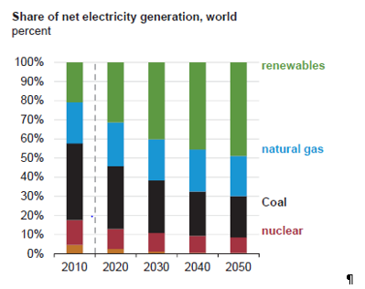All the projections for the future electricity supply, including that of the IPCC, envisage nuclear power to provide an important contribution to the electricity supply even in a distant future. Most of the studies foresee not more that 50% of the variable renewable energy (VRE) in the electricity mix in 2050. It is obviously that for the total decarbonisation either nuclear or gas/coal with CCS are essential, where nuclear remains only readily available technology. For countries that do not have hydraulic power, or can’t afford enormous areas to be devoted to biomass, nuclear remains the only choice for full decarbonisation.

Worth noting is that nuclear is a dispatchable source of electricity, have extremely high energy density (i.e. takes little space for large amounts of energy), and proven capability for the load following to regulate the grid. The notion that VRE could cover the entire needs for electricity, without Hydraulic power, is physically impossible. Instead of relying on very high cost solutions like grid-scale batteries (cost above 150 Euro/MWh) or power to power via hydrogen to generate electricity (400 Euro/ MWh), nuclear is an obvious choice.

**System costs**

System costs are defined as the total costs accrued beyond the perimeter of a power source, supply electricity at a given load and given level of security of supply. System cost include profile costs (i.e. cost of back up for non-dispatchable electricity i.e. VRE), balancing costs, grid costs and the connection costs.

The system costs of continually dispatchable sources as nuclear or coal/gas are very small, in the order of 2 Euros/MWh. With a low penetration of VRE, the system costs remains small, as there are enough reserves to balance the grid when VREs are not generating. With an increased penetration of VRE, and in particular above about 50%, the system costs become a dominant contributor, as documented in the research of the IEA.

The decarbonation of electricity with only VRE is a choice between very high costs and accepting regular blackouts. Availability of VREs (solar or wind) are internally closely related, i.e. non redundant: doubling the amount of PV panels will not add to overnight supply; all windmills would stand still when there is no wind in the North sea. Thus, more VREs in the system, more reserve sources are needed to secure the supplies.

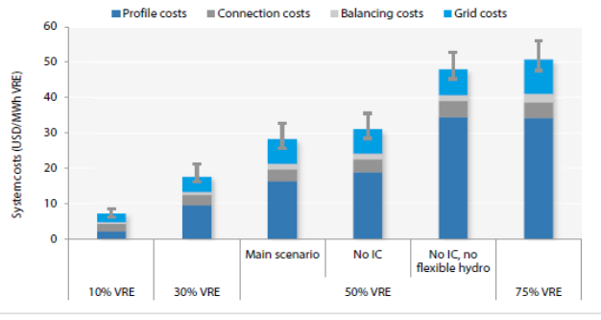 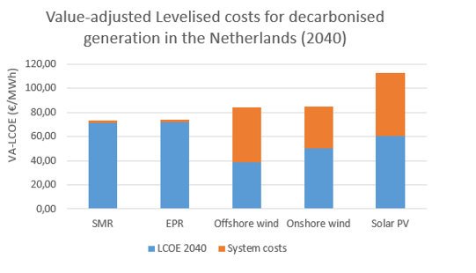

The studies analysing VRE penetration often ignore system cost by projecting from the current situation with 10-20% penetration. Sometimes “low” system costs are justified with the assumptions that electricity will be unavailable for certain amount of time, which is very likely not acceptable to today’s society. Furthermore, typically advertised “low cost of VRE” exclude the connection cost, which in a case of off shore wind becoming a dominate contributor. On the contrary, nuclear is constantly dispatchable, able to balance the grid and its investment costs already include the grid connection.

**Cost of nuclear**

Often raised drawback for nuclear power is that it is just too expensive”. Typical evidence for such comes from two long-delayed projects in the EU, Flamanvile and Olkilouto. It is indeed so that expensive projects that are unfinished for a decade or more always result in enormous cost, this being an airport (BER, factor of 3) or a railway (Crossrail, factor of 3.5 and counting). A looks into the costs profile of new nuclear reveals that the majority is the costs of capital, i.e. interest paid. For the Hinkley point NPP in construction in the UK, about 65% of the total cost of the plant is associated with interest payment.

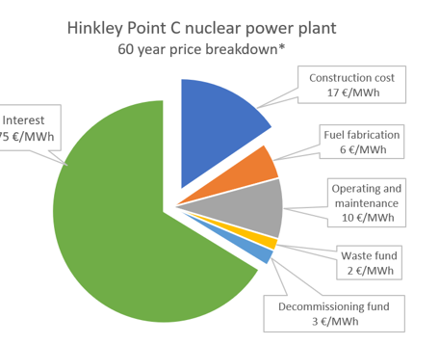 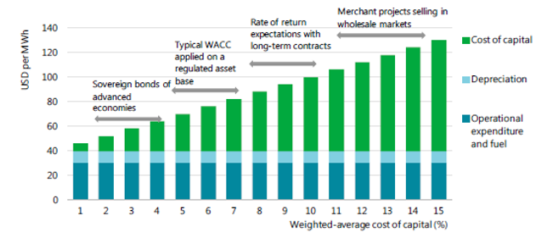

It is obvious that with the cost of capital as it is in the EU today (zero or negative interest rates), having an investment model where two thirds of the cost is to cover interest is not sustainable. When the cost of the capital (WACC) is in the range of 4 %, nuclear is fully competitive with other sources of carbon free electricity.

To explore costs of nuclear, considering system, operation and decommissioning costs, etc, ENCO modelled the cost of various non carbon emitting electricity sources for the Netherlands in 2040, with interest of 7%.

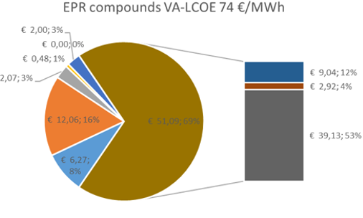 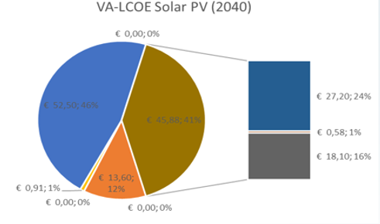 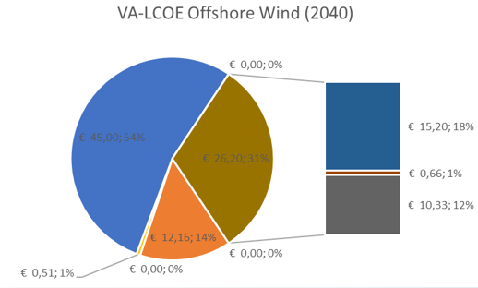

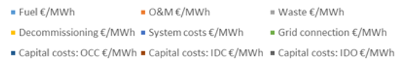

It is rather obvious that, when considering system costs with the penetration of VREs even at 50%, nuclear is cheaper than off shore wind and significantly cheaper than photovoltaic. This is even before other (positive) externalities are considered, e.g. the lifetime of nuclear plants being 60 or even 80 years while the VREs at best last for 25 years, or that the spatial impact of nuclear is a minuscule fraction of VREs, or that the cost of nuclear already include provisions for decommissioning and safe disposals of all residues that is not the case with VREs (PV panels cannot be recycled with technologies available today).

Possibly the most relevant finding from the ENCO study is that in the situation where *the level playing field* for all non-carbon emitting sources for electricity is in place, nuclear is fully competitive and dominates other sources in several areas. The current situation where VREs are effectively *subsidized by having guaranteed income* (i.e. all VRE generation is taken by the grid and paid for a predetermined price, regardless of the need for such electricity) will be impossible with higher penetration of VRE (some will have to periodically shut down). This, together with system costs, further undermines the competitiveness of VREs. On the contrary, nuclear with its guaranteed dispatchability and reliability of supply, when financed with capital costs that is prevailing in the markets today, becomes the most affordable non carbon emitting source of electricity.