**THE APPLICATION OF THE NEW EU ECONOMIC GOVERNANCE**

**Italy’s economic-fiscal situation and its fiscal-structural plan**

*Hearing before the Finance Committee of the Tweede Kamer, the House of Representatives of the Netherlands, 18 January 2025*

*by Lorenzo Codogno\**

*Over the past few years, various shocks have affected EU economic growth and public accounts, raising many issues and prompting significant policy responses. Does the new EU governance framework deliver on its intended purpose and help Italy address its public finance problems? I look at Italy’s Medium-Term Fiscal-Structural Plan and whether it allows budgetary consolidation while enhancing economic growth. My conclusion is that, despite all the criticism, the new economic framework substantially improves the previous approach and will help Italy strengthen its public finances and reduce its debt. However, in itself, it is no guarantee of success.*

To quote the British economist Sir Dieter Robin Helm, “If something is unsustainable, it will not be sustained”. This should be the working assumption of EU countries in their approach to public finances. A medium-term path for public finances and the debt trajectory must be designed and diligently implemented, regardless of whether there will be a central fiscal capacity or a shared financing for common goods in the future —which, in my view, are desirable. So, the issue is whether the new EU economic governance delivers on its intended purpose and whether Italy’s plan will credibly address public finance problems while enhancing economic growth. On this occasion, I will not discuss the new economic governance framework in detail, only the specific features relevant to the Italian situation.

On 29 April 2024, the Council adopted the reform of EU fiscal rules. Later, the Commission sent the reference trajectories for the new net expenditure path to countries (which were then published on 15 October). On 26 July, following the Commission’s proposal on 21 June, the Council of the EU adopted decisions establishing the existence of excessive deficits for eight countries, including Italy. On 26 November, the Commission adopted an overall communication, assessing Medium-Term Fiscal-Structural Plans and bringing the new economic framework to life.

The EDP procedure was a blessing in disguise for Italy as it allowed a more gradual and realistic fiscal adjustment in line with the requirements of the new governance framework. According to the net expenditure path recommended by the European Commission, the expenditure aggregate is required to grow no more than 1.5% per year on average in nominal terms in 2025-2031, which would be in keeping with an ex-ante improvement in the structural primary balance of 0.6pp per year.

Let me make a few statements, unfortunately, without supporting arguments due to time constraints:

1. The new fiscal-structural economic framework allows for a long-term planning horizon and a realistic and sustainable medium-term path, with gradual fiscal adjustment and enhanced ownership. It is particularly relevant for Italy, where no such long-term plan existed in the past. For Italy, placing its high debt on a plausibly downward trajectory at the end of the adjustment period is of the essence. The framework also guarantees the necessary flexibility in the case of unforeseeable shocks.
2. The new framework addresses the pro-cyclicality of the existing Stability and Growth Pact (SGP), although its implementation will be crucial.
3. The stated aim of simplifying the framework was only partly achieved. New technical details related to Debt Sustainability Analysis (DSA) are even more complex than those of the past framework, which, to some extent, had to be expected. On top of that, some unnecessary complications and safeguards were added.
4. Yet, the new focus on Debt Sustainability Analysis (DSA) is very much welcome. It provides a correct incentive structure and allows policymakers to streamline communication on public finances, focusing on what matters for debt sustainability.
5. The separation between public finance rules and long-term demographic and ageing projections was overcome. This is relevant for Italy as it has one of the most challenging demographic trends in the EU.
6. Linking fiscal plans with reforms and public investment ensures greater coherence of the overall economic policy framework and emphasises the overreaching goal of enhancing economic growth over the medium term. It establishes the correct tradeoffs.
7. However, I noticed a fiscal multiplier of 0.75 in the Commission’s guidance to Italy. I believe this value tends to overstate the impact of fiscal consolidation on economic growth. While, in some instances, reducing public spending affects GDP one-to-one, the general equilibrium effects seem neglected by such a high multiplier. There are ways to design an expenditure-based fiscal consolidation in a growth-friendly way, limiting the near-term adverse impact on economic performance. By depressing projected economic growth, a high multiplier tends to show only a moderate improvement in the headline budget balance. At any rate, I am sure these technical issues will be addressed and the methodology fine-tuned over time.
8. Net expenditure is defined as primary expenditure (i.e. excluding interest) less cyclical components linked to unemployment developments, expenditure on EU programmes fully or partly financed by the EU, one-off or temporary budgetary measures and discretionary changes on the revenue side. This is the correct aggregate for Italy and other EU countries. However, the door should remain open to refinements of the aggregate over time to ensure it avoids pro-cyclicality.

Besides the above general comments on the new framework, two past events will significantly affect the trajectory of Italy’s public finances and economic performance over the next three/four years: (1) NGEU/RRF spending and the effects of more vigorous investment activity on potential growth, and (2) the effects of the so-called Superbonus 110%, the generous subsidy scheme for energy-efficient renovation of residential buildings.

Italy is the country that benefitted the most in the allocation of NGEU-RRF funds in euro terms and is among the largest beneficiaries as a percentage of GDP/GNP. Despite some delays, this should have allowed a substantial stimulus to economic activity. However, the expected positive effect on GDP was smaller than expected over the past four years. Italy did a reasonably good job complying with the milestones and targets, allowing the Commission to release payments. Yet, spending appears to lag. Reliable time series of actual expenditures are missing (although they should be available in the electronic platform used by the government). Due to delays, the impact on growth should become sizeable in the final rush to complete the projects by the mid-2026 deadline.

Estimating how much NGEU-RRF spending has supported economic activity since the pandemic is tricky. There could have been three effects at play. First, the total amount of projects considered ‘additive’, i.e. that would not have happened without EU funds, might be much smaller than initially envisaged by the government (Figure 1). Second, despite ticking the boxes to receive EU funds, Italy’s delays in the implementation of the projects might be more substantial than currently publicised. Third, it may be that the prudent multiplier used by the Commission and the Italian government (i.e. close to 1) is still too generous, and the projects cannot generate the expected GDP impact due to waste, effects that go beyond the forecast horizon, capacity constraints or else.

In the first and third cases, no substantial stimulus to economic activity should be expected by the programme’s final deadline. In contrast, in the second case, activity might surge over the next year and a half.

Moreover, the enhancement in potential growth NGEU-RRF reforms and investments can generate over the long run remains uncertain. Again, taking the cumulative effect of short-term multipliers, growth should have already been more vigorous than recorded over the past four years, which does not bode well for the long-term effects.

The other uncertainty factor relates to the so-called Superbonus 110%, which blurred the reading of economic performance and public finances over the past four years. In 2020, amid one of the most dramatic crises in living memory, the Italian government made an unprecedented move by introducing the so-called Superbonus 110%. It was a generous subsidy scheme to allow the energy-efficient renovation of residential buildings as a policy response to the economic challenges posed by the pandemic. It differed from previous schemes, which were far less successful. With the modifications introduced in 2020, the take-up of the Superbonus suddenly took off beyond any expectations. This was related mainly to two factors:

1. The increase of the tax benefit to 110%, i.e. exceeding the actual expenses incurred in undertaking the works, i.e. a sort of free lunch.
2. The possibility of transferring the tax credits, which allowed taxpayers with limited tax capacity to benefit from it.

It ended up impinging on the same sectors supported by the EU-funded investment plan, resulting in significant capacity constraints and misallocation of resources. Its excessive generosity brought a massive deterioration in public finances, while its returns in terms of economic growth were short of expectations.

Since its launch, the take-up of the programme has skyrocketed from the initial estimate of only €36.6 billion to something close to €120 billion (almost €200 billion, i.e. nearly 10% of GDP, including other similar existing schemes). The use of tax expenditure to support residential construction had increased over the years, even before 2020, and the policy aim was not to use it as an emergency countercyclical tool but instead as a way to achieve the energy-transition goals, on expectations that the plan would have, by and large, been self-financing.

The whole initiative can be considered a textbook example of how policymakers can mess up the incentive structure entirely and, thus, the smooth functioning of a market economy despite some near-term countercyclical benefits. Past estimates of the Superbonus impact on GDP and public finances assume a substantial part is ‘additive’, i.e. it would not have happened without the fiscal benefit. This does not appear to be supported by the recorded economic performance. Moreover, they assume limited capacity constraints on the supply side. Instead, subsidised activity has squeezed out other types of building activity, given the severe limitations on companies’ capacity to deliver. In other words, messing up with demand may have produced undesirable and unexpected distortions on the supply side of the economy and deadweight losses.

While it is adequate to support demand following a big shock such as the pandemic-induced recession, housing incentives have little impact over time on the productive capacity of the economy. In an economy with limited resources and financing, a massive subsidy scheme like the Superbonus 110% crowds out investment in more productive and technologically advanced sectors, determining an unfavourable reallocation of resources.

Moreover, the costs to public finances have sharply increased. Due to the ruling by statistical offices, the effects on the Maastricht-definition accrual deficit were frontloaded. In 2021-2024, it was almost fully expensed. In contrast, the cash impact on net borrowing and debt is delayed, and most of it is yet to come (Figure 2). There are no updated official estimates on this matter. However, my estimates show that it boosted the Maastricht-definition accrual deficit by 1.8pp in 2021, 2.4pp in 2022, 2.7pp in 2023, and a much smaller 0.9pp in 2024. Following the phasing out decided by the current government, the use of the scheme almost wholly ended in March 2024. This will allow Italy’s deficit to decline from 7.2% in 2023 to an estimated 3.8% in 2024. The impact should be less than 0.1% of GDP in the coming years.

The Superbonus will keep the debt ratio high for several years. The impact is estimated between 1.8 and 1.9pp in 2024, 2025 and 2026, then declining to 1.1pp in 2027 and gradually disappearing thereafter. It will also depend on taxpayers’ behaviour, their capacity to offset tax payments with tax credits, and economic growth, and thus, it is subject to considerable uncertainty.

Putting together NGEU-RRF public investments and the Superbonus, the economic impact of the demand stimulus was far short of expectations. However, it is not straightforward to disentangle these effects from the general trend of the economy. Should the impact have been more significant than my estimates, it would shed a bad light on Italy’s underlying economic performance since the pandemic, i.e. net of the demand stimulus.

According to the government’s estimates, the reforms attached to NGEU-RRF have already increased GDP by 1.1pp relative to the baseline. Assuming full implementation, this will grow to 3.1pp in 2028 and 6.0pp in 2050. The mentioned reforms have probably gone under the radar screen of media attention, and maybe that was a deliberate strategy by the government to make them more acceptable to public opinion. At any rate, the current evidence on reforms does not allow many reasons for optimism about their long-term impact.

Amid these uncertainties on the interpretation of Italy’s economic and public finance performance since the pandemic, some factors have favoured what I would define as ‘fiscal consolidation by stealth’. The spike in inflation in 2022 and 2023 was related to a terms-of-trade shock, i.e. much higher costs for energy that made European economies poorer. Thus, it also damaged public finances. However, it also facilitated the political economy of fiscal consolidation.

First, social security contributions surged due to the job-rich nature of the post-pandemic recovery. Second, revenues from indirect taxes (i.e. VAT) rose due to higher inflation. Third, there was an increase in direct taxes as the government decided not to adjust tax bands (Figure 7). Finally, there was an improvement in tax compliance, which started before the pandemic and accelerated with the increased digitalisation of the economy.

Since the pandemic, the sharp improvement in the labour market has been Italy’s most favourable economic development. There has been a remarkable performance, with unemployment declining from 9.8% at the end of 2019 to 5.8% in October 2024 and the employment rate rising from 59.0% of the labour force to 62.5%. Labour participation has also increased, with the activity rate rising from 65.5% to 66.4%, still below top-performing EU countries but steadily improving (Figure 5). Since 2019, about 1 million jobs have been added. Despite being disproportionately linked to the construction and, to a lesser extent, tourism sectors and not high-paid jobs, this phenomenon has nevertheless been hugely positive for the economy and public finances. Amid a substantial drop in rates, social security contributions declined only modestly in real terms and as a percentage of GDP (12.6% in the second quarter of 2024 vs 13.3% in 2019) while allowing reduced social spending.

Second, tax bands are not automatically adjusted in Italy. Therefore, inflation pushed up tax revenues as taxpayers ended up in higher tax brackets. The 4-quarter moving average of direct taxes as a percentage of GDP has reached 15.4%, the highest rate ever. In the first quarter of 2024, the tax burden peaked at 43.4%, second only to the spike recorded in the second quarter of 2013 following the sovereign debt crisis. Compliance also increased, as documented in the Medium-Term Fiscal-Structural Plan and quantified at €4.7 billion over 2021-2024, due to ongoing efforts by the tax agency to fight tax evasion.

Moving to indirect taxes, the surge in inflation resulted in higher revenues. VAT tax compliance also increased, as documented in the Medium-Term Fiscal-Structural Plan and quantified at €3.8 billion over the period, primarily due to the introduction of electronic invoicing. Tax compliance results have been encouraging, and official estimates support the idea that a significant part of higher receipts can be considered as enhancing revenues permanently (emergence of tax base).

Yet, the outlook remains challenging. Some favourable phenomena will disappear in the future, and others will no longer show improvement. A spending path allowing a 1.5% increase per year would effectively represent a reduction of 0.5% in real terms. Such a reduction will be hard to achieve without reorganising public services substantially. Moreover, spending on pensions is the trickiest to reduce due to demographic trends and the political sensitivity of the matter (Figure 8).

On the positive side, some other estimates may prove too cautious. Potential growth is currently officially calculated at close to 1.0%. Projections point to a steady decline towards 0.2% in 2033 and then improvement back to 1.4% in 2041 (Figure 6). The slump and recovery do not appear to match demographic changes or the estimated effects of structural reforms. Moreover, real GDP growth is expected to average 0.5% over the next ten years, which is not entirely consistent with the estimated impact profile of reforms and investments. Moreover, as mentioned above, the high fiscal multiplier tends to overstate the negative impact of fiscal consolidation on economic growth. Finally, implicit interest rates are projected to increase steadily towards 4.1% by the end of the forecast horizon vs. 3.0% for 2024. Interest expenditure as a percentage of GDP is anticipated to reach a peak of 4.8% in 2034 vs 3.9% expected for 2024 (Figure 9). If fiscal consolidation continues and yield spreads narrow, interest expenditure may be lower than projected.

The new fiscal framework allows Italy to implement budgetary consolidation while credibly pursuing reform and investments and enhancing economic growth. Despite some problems, it substantially improves the previous approach. However, some factors that have recently helped Italy start fiscal consolidation may gradually vanish. At the same time, the legacy of past misguided policies (Superbonus) will be felt for a few more years, and the uncertain impact of NGEU-RRF investments and reforms will blur the picture. Reducing public current expenditure by half a percentage point per annum in real terms will prove increasingly tricky also in light of demographic trends. So far, the current government has been guided by a credible commitment to fiscal consolidation. No matter how good the new framework is, this attitude would also have to be maintained in bad times, when fiscal consolidation may start colliding with the political objective of maintaining voters’ support. In itself, the new economic framework is no guarantee of success.

**Figure 1.**

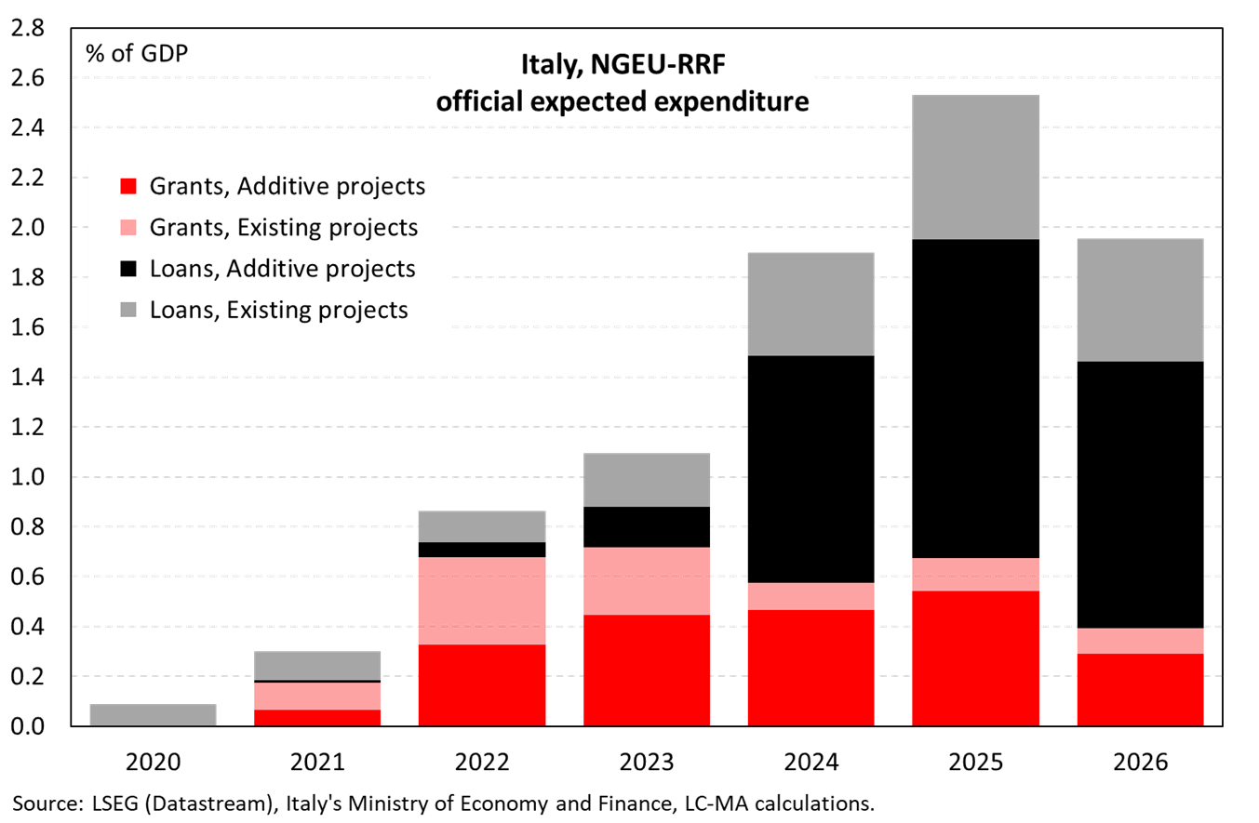

**Figure 2.**

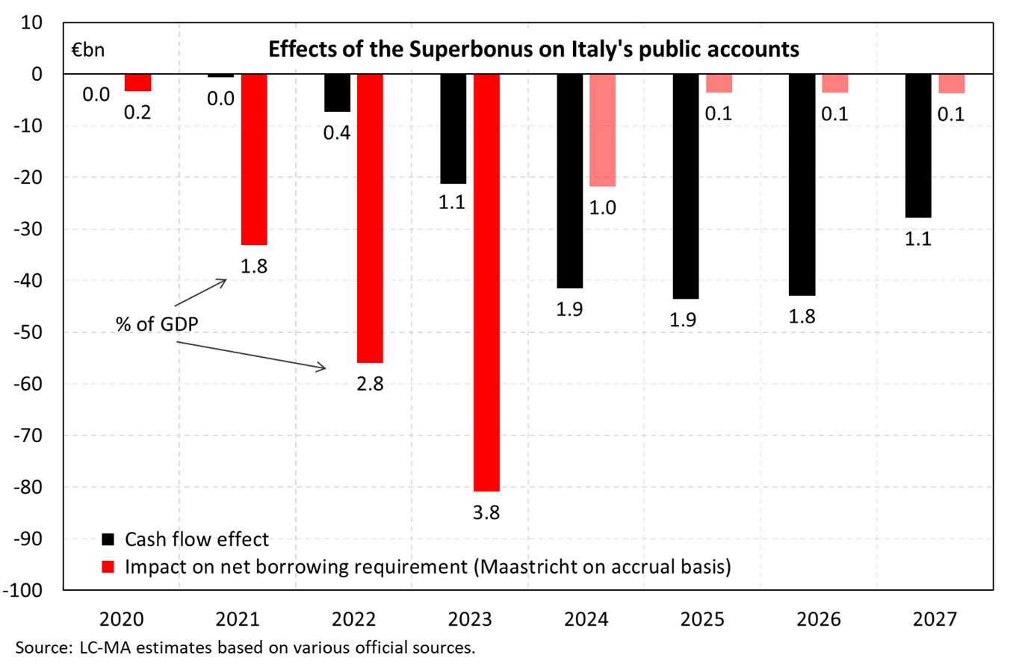

**Figure 3.**

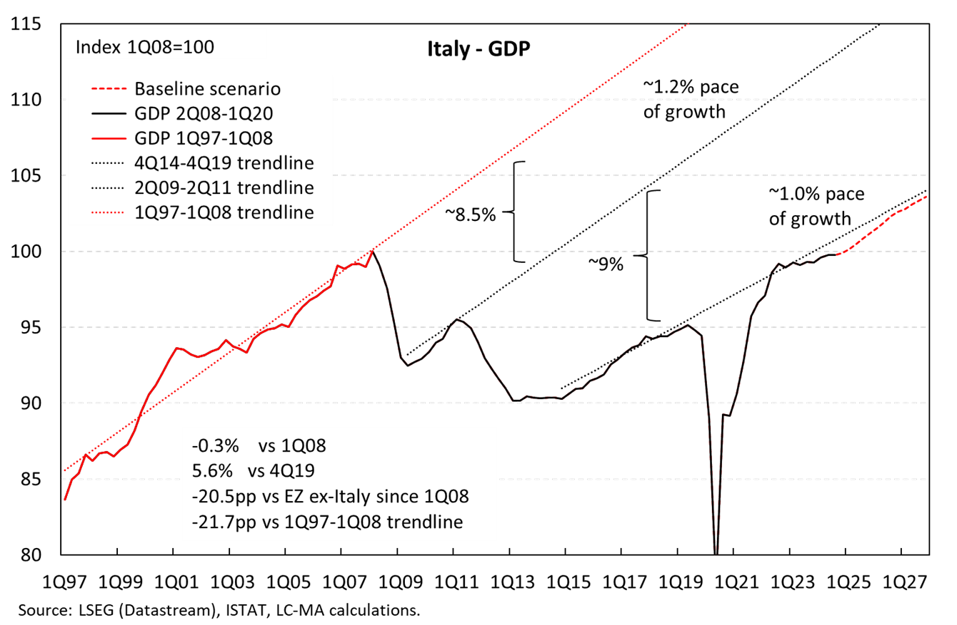

**Figure 4.**

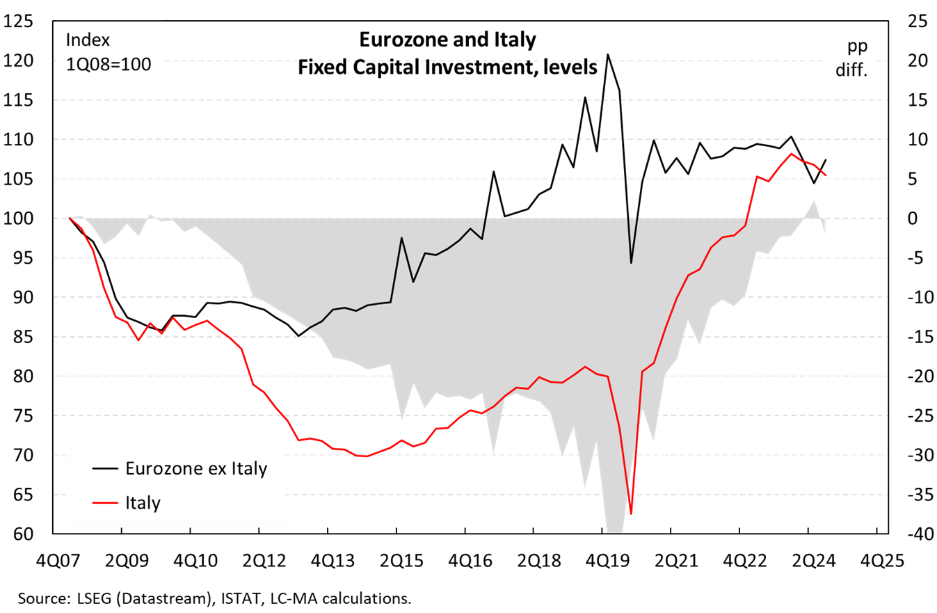

**Figure 5.**

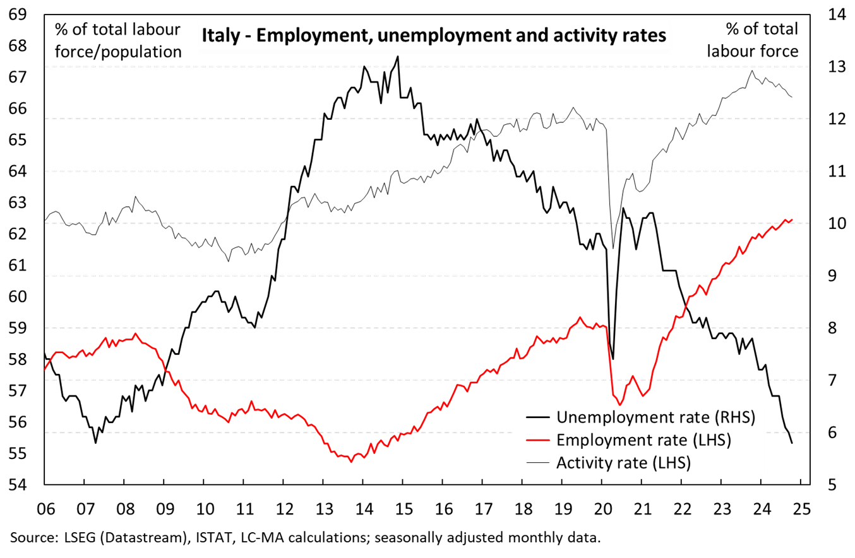

**Figure 6.**

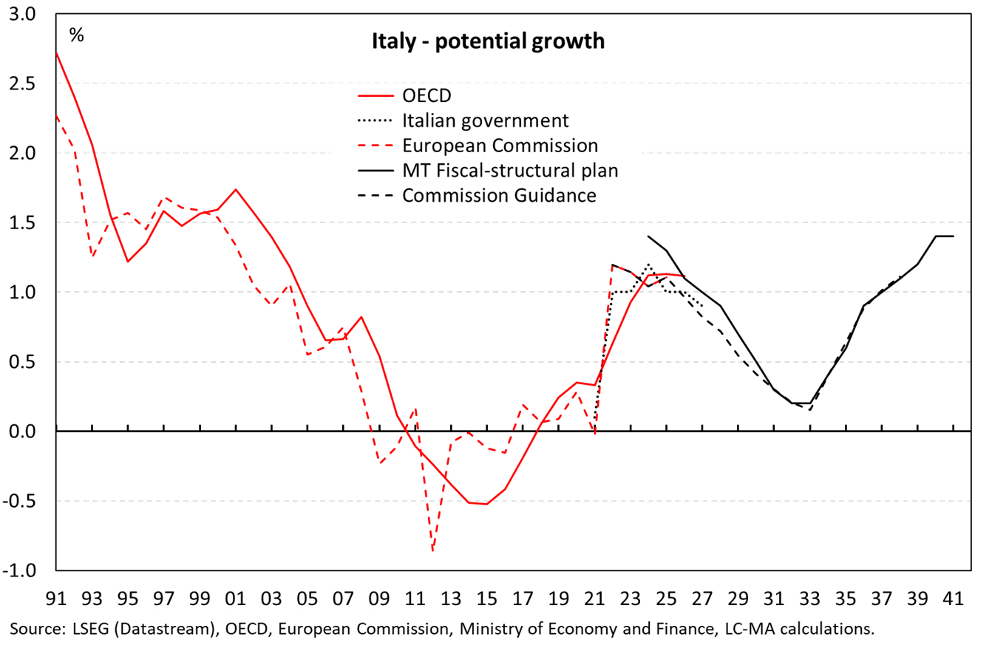

**Figure 7.**

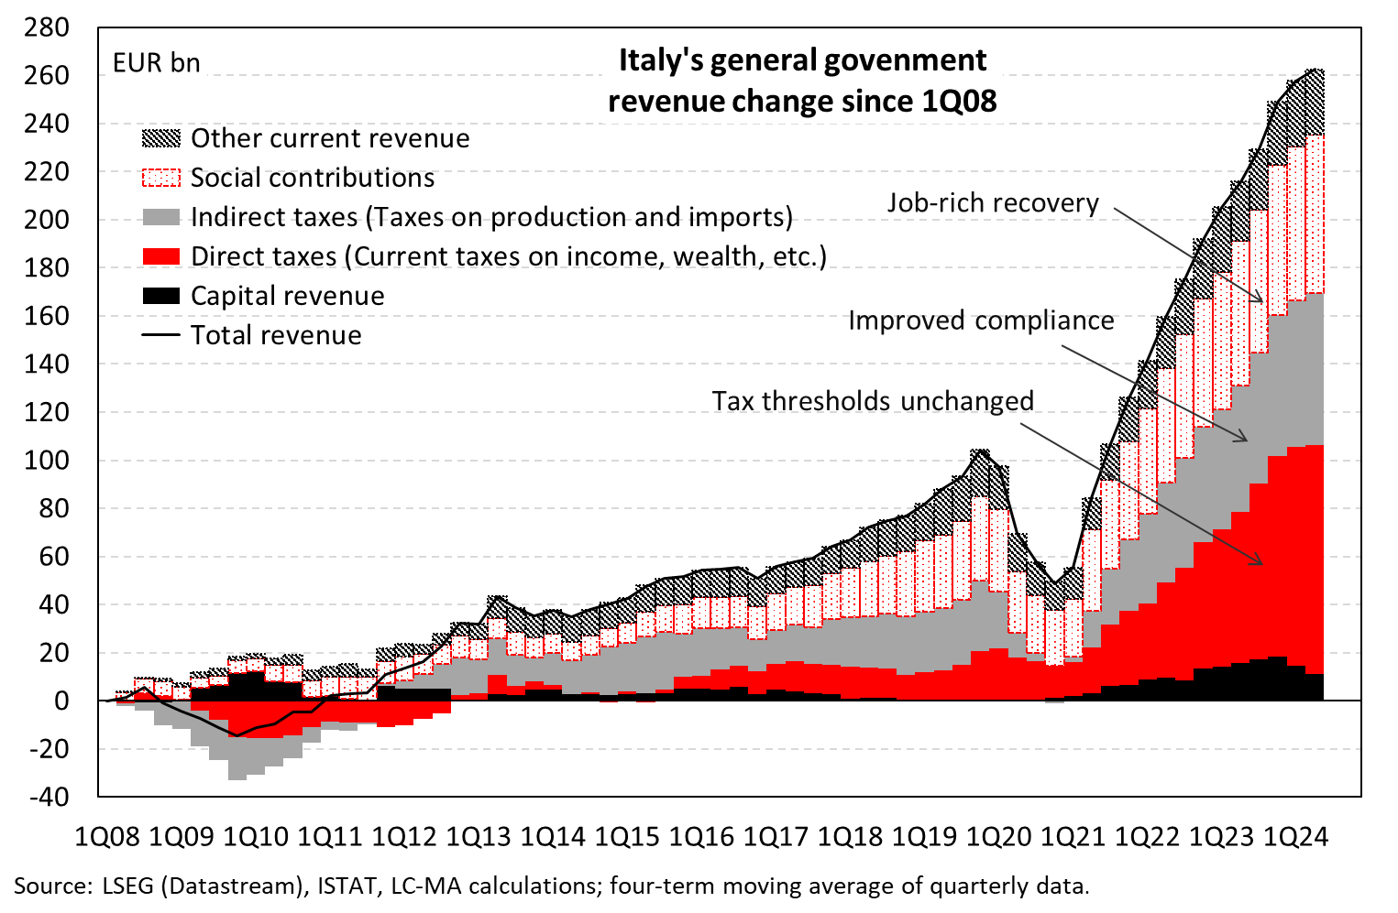

**Figure 8.**

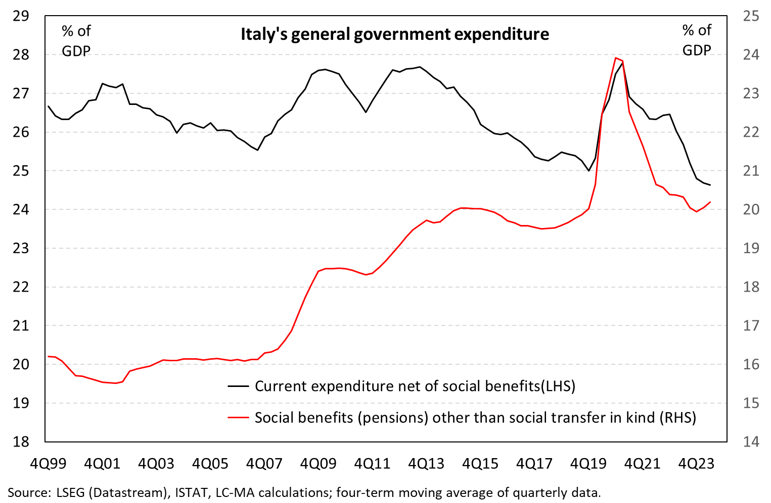

**Figure 9**

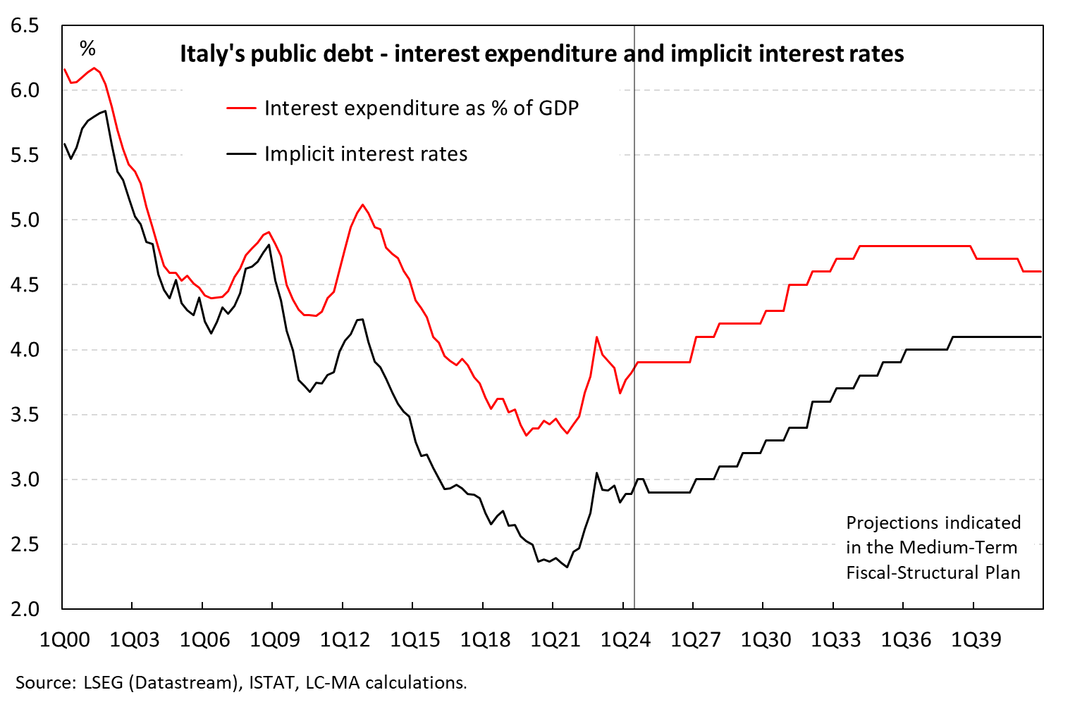

**Figure 10.**

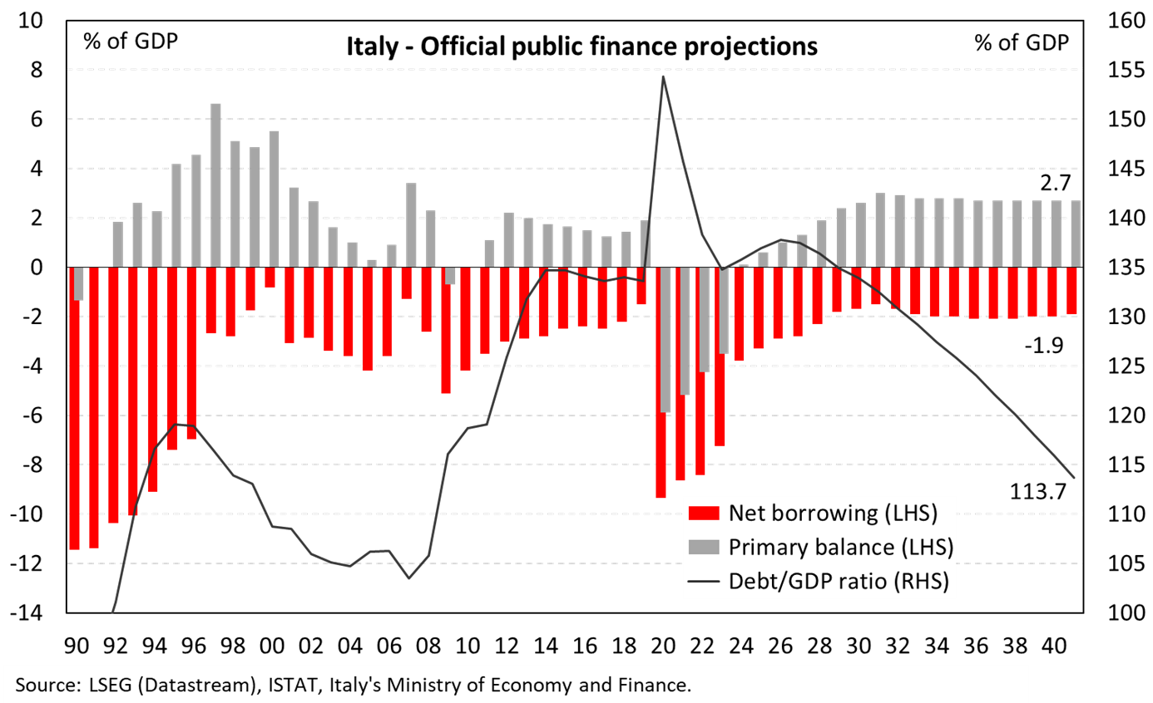

**\*Lorenzo Codogno** *– Visiting Professor in Practice at the London School of Economics and Political Science and the College of Europe, Bruges; senior fellow at LUISS LEAP.*

Lorenzo Codogno is a Visiting Professor in Practice at the LSE’s European Institute and founder and chief economist of his own consulting vehicle, LC Macro Advisors Ltd. Lorenzo is also a Visiting Professor at the College of Europe, Bruges and senior fellow at LUISS LEAP. Prior to joining LSE, Lorenzo Codogno was chief economist and director general at the Treasury Department of the Italian Ministry of Economy and Finance (May 2006-February 2015). Throughout this period, he was head of the Italian delegation at the Economic Policy Committee of the European Union, which he chaired from January 2010 to December 2011, thus attending Ecofin/Eurogroup meetings with Ministers. He also represented Italy at the OECD (EPC, WP1 and EDRC) and was Chair of WP1. He joined the Ministry from Bank of America, where he had worked over the previous 11 years. He was managing director, senior economist and co-head of European Economics based in London. Before that, he worked at the research department of Unicredit in Milan.