DEPUTY MINISTER
ROMAN VASSILENKO
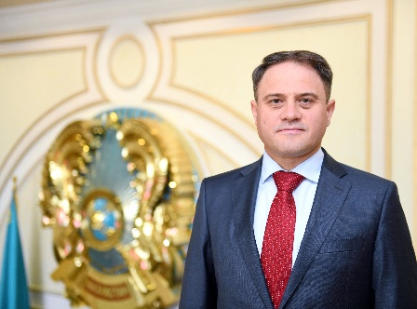

Roman Vassilenko was born in 1972 in Shymkent.
He graduated with honors from the Military Academy of Economy, Finance and Law of the Armed Forces of the Russian Federation in 1994, receiving a degree as a referent interpreter and an expert in international law.
From 1994 to 1996, he served on the staff of the International Relations Department of the Presidential Administration of the Republic of Kazakhstan.
He has been on Kazakhstan's diplomatic service since 1996, first as Third Secretary and later as Second Secretary at the Embassy of Kazakhstan to the United Kingdom of Great Britain and Northern Ireland.
In 1999-2000, he worked as Assistant to the Head of Prime Minister's Office of the Republic of Kazakhstan.
In 2000-2007, he served as First Secretary and later as Counsellor of the Embassy of Kazakhstan in the United States.
In 2007-2009, he worked as Chief Inspector of the Secretariat of the Secretary of State of Kazakhstan; Consultant of the President's Chancery of the Republic of Kazakhstan, and Deputy Chief of Staff to the Secretary of State of Kazakhstan.
In 2009-2012, he served as Chairman of the Committee for International Information of the Ministry of Foreign Affairs of Kazakhstan, overseeing the communications for the Ministry during such important periods as Kazakhstan's chairmanships in the Organization for Security and Cooperation in Europe (2010) and the Organization of Islamic Cooperation (2011-2012).
In 2012-2013, Roman Vassilenko worked as Deputy Director of The Nazarbayev Center, a multifunctional scientific, analytical, humanitarian and educational public institution.
In 2013-2014, he worked as Ambassador-at-large at the Ministry of Foreign Affairs overseeing the global communications efforts of The ATOM Project, among other activities.
In 2014-2016, he again served as Chairman of the Committee for International Information of the Ministry of Foreign Affairs.
On March 4, 2016, by the resolution of the President of the Republic of Kazakhstan, Roman Vassilenko was appointed Deputy Minister of Foreign Affairs of the Republic of Kazakhstan.
He holds the diplomatic rank of Envoy Extraordinary and Plenipotentiary of First Class.
He speaks English, French and Vietnamese. He is awarded with the medal “For Valorous Work" (2008) and the order “Qurmet" (Honour) and numerous commemorative medals.
He is married with three children.

