http://www.janes.com/article/54311/afa-2015-russia-has-closed-air-power-gap-with-nato-us-warns?utm_campaign=PC6110_E15%20DF%20NL%20Security%2009_22_15&utm_medium=email&utm_source=Eloqua
n.a.v. dit bericht wil ik in de volgende procedure-vergadering van de cie Defensie voorstellen om te vragen om een technische briefing over dit onderwerp. Wat betekent dit feitelijk voor eventuele inzet van onze
huidige militaire luchtvaartuigen en voor de luchtvaartuigen die de komende jaren worden aangeschaft?

Military Capabilities

AFA 2015: Russia has closed air power gap with NATO, US warns
Marina Malenic, Washington, DC - IHS Jane's Defence Weekly
16 September 2015
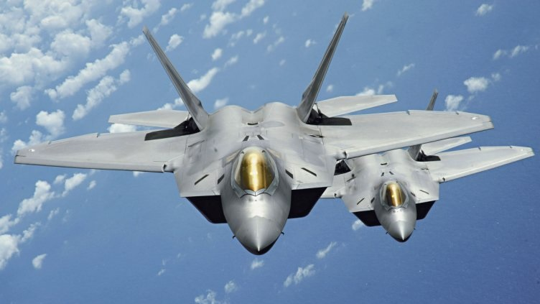
Stealthy combat aircraft such as the F-22, four of which returned from an August deployment to Europe as part of the Pentagon's ERI, are needed to counter Russia's burgeoning A2/AD threat on the continent. Source: USAF

Key Points
- Russia's military modernisation has diminished NATO's air superiority in Europe
- The Pentagon is most alarmed by Russia's ability to create A2/AD challenges
Russia's military modernisation has diminished NATO's air superiority in Europe, US Air Force (USAF) General Frank Gorenc, the commander of US Air Forces in Europe and Africa, said during the Air Force Association's annual symposium on 14 September.
"They have closed the gap," Gen Gorenc, also the chief of Allied Air Command, told reporters during a briefing.
"The advantage that we have from the air, I can honestly say, is shrinking," he added. "But the more alarming thing is their ability to create anti-access/area denial [A2/AD]."
Following difficulties that Moscow experienced during the 2008 invasion of Georgia, Russia initiated "a very large modernisation", Gen Gorenc said. "They learned a lot along the way, and they made moves to close the asymmetric advantage posed by the quality of our air force; they've done it."
Gen Gorenc is particularly concerned about two A2/AD zones - Crimea on the Black Sea and Kaliningrad on the Baltic Sea. "Some of the array that's in Kaliningrad extends into Poland today," he said. "That's a fact."
Meanwhile, the four USAF Lockheed Martin F-22 Raptor combat aircraft that arrived at Spangdahlem Air Base in Germany on 28 August for training have returned to the United States. The training was designed to prove the fifth-generation fighter jets can successfully deploy to European bases and other NATO installations, as well as to familiarise pilots with the regional theatre.
The deployment also allowed US forces a chance to conduct combat air training with different US and European aircraft. The Pentagon first announced the deployment on 24 August as part of the European Reassurance Initiative (ERI) that seeks to boost the confidence of US allies concerned about Russian activity in Ukraine.
The USAF in June began its ERI efforts with the temporary deployment of three Boeing B-52H Stratofortress and two Northrop Grumman B-2 Spirit bombers to the United Kingdom, and eight Fairchild-Republic A-10C Thunderbolt II attack aircraft to Estonia. More aircraft have been deployed since.
Want to read more? For analysis on this article and access to all our insight content, please enquire about our subscription options ihs.com/contact

