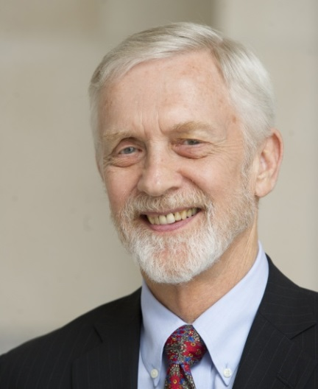

William H. Hill
Expertise : Europe Russia and Eurasia
Affiliation : Former Professor of National Security Strategy, National War College, Washington D.C.
Wilson Center Projects : "Post-Cold War Euro-Atlantic Security Institutions"
Term: Oct 02, 2017 — Sep 30, 2019

Bio
William Hill is a Global Fellow at the Wilson Center. A retired Foreign Service officer, Dr. Hill is an expert on Russia and the former Soviet Union, east-west relations, and European multilateral diplomacy. He served two terms – January 2003-July 2006 and June 1999-November 2001 – as Head of the OSCE Mission to Moldova, where he was charged with negotiation of a political settlement to the Transdniestrian conflict and facilitation of the withdrawal of Russian forces, arms, and ammunition from Moldova.

Previous Terms
Oct 01, 2001 - Jun 01, 2002: "European Security Institutions Since the Cold War: The Changing Roles of NATO and OSCE" Aug 2014-June 30, 2015: Public Policy Scholar: "Post-Cold War Euro-Atlantic Security Institutions"

Books

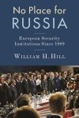
No Place for Russia: European Security Institutions Since 1989

