Bijlagen

Tabel A1. Experts-interviews voor deze factsheet
Geconsulteerde experts
No | Expertise-land | Naam | Organisatie
1 | Denemarken | Thomas Gammeltoft-Hansen | Universiteit van Kopenhagen
2 | Denemarken | Nik Tan | The Danish Institute for Human Rights
3 | Denemarken | Cecilia Vejby Andersen | Mixed Migration Centre
4 | Noorwegen | Cathrine Talleraas | CMI, EFFEXT Project
5 | VK | Oliver Bakewell | Universiteit van Manchester
6 | VK | Alexander Betts | Universiteit van Oxford
7 | Nederland | Myrthe Wijnkoop | ACVZ
8 | Nederland | Janneke van Etten | BUZA
9 | Duitsland, Ethiopië | Sabine Mohamed | Max Planck Institute Göttingen
10 | Europese Commissie | Elisa Benker | Sciences Po

Tabel A2. Internationale en EU frameworks voor de bescherming van vluchtelingen
Level | Framework | Description
Global | Comprehensive Refugee Response Framework, 2016 | The CRRF is a set of commitments to addressing the large-scale movements of refugees. It identifies four areas of action: (i) reception and admission measures; (ii) support for immediate and ongoing needs; (iii) support for host countries; and (iv) enhanced opportunities for durable solutions. This framework was the first to link humanitarian action with development assistance. In this approach, host countries would benefit from support with reception mechanisms and in providing humanitarian and security measures  while making improvements to local conditions to enable return and alleviate pressure on host countries. The CRRF stressed meeting immediate and ongoing needs in countries of origin, supporting admission measures in host states and encouraging regional responsibility sharing through durable solutions.
 | Global Compact on Refugees, 2018 | Building on the principles of the CRRF, this framework sets out voluntary contributions to achieve collective outcomes under the principles of burden- and responsibility-sharing to better protect and assist refugees, and support host countries and communities. The main objectives are to: (i) ease pressures on host countries; (ii) enhance refugee self-reliance; (iii) expand access to third country solutions; and (iv) support conditions in countries of origin for return in safety and dignity. To operationalize burden- and responsibility-sharing this framework proposes: humanitarian assistance for emergency and protracted refugee situations; development cooperation for host countries beyond regular development resources; maximizing private sector contributions, to create jobs and introduce innovative technology, financial products and information services for refugees and host communities. Among potential partners, we find humanitarian and development actors, UN agencies, national parliaments, networks of cities and municipalities, local authorities and local actors, civil society organizations, faith-based actors, academics, sports and cultural organizations and public-private partnerships.  The Global Compact aims to facilitate access to durable solutions, which include voluntary repatriation, resettlement and local integration. While the preferred solution is voluntary repatriation (within the boundaries of non-refoulement), the Compact includes a plea for more resettlement as well as complementary pathways for admission to third countries including family reunification, private or community sponsorship programmes, humanitarian visas, scholarships and student visas, and labour permits for refugees. Local integration is a big component of this framework, emphasizing a move towards the local integration of refugees, with the ultimate objective of durable legal status and naturalization. Refugees and new asylum seekers should access: various forms of protection including security screenings and health assessments of new arrivals; food security and nutrition; education, vocational training, language skills, and access to the labour market. Moreover, partner must include actions to ensure the peaceful coexistence of refugees and host communities.
 | Global Compact for Safe, Orderly and Regular Migration, 2018 | This cooperative framework fosters international cooperation among all relevant actors on migration to optimize the overall benefits of migration, while addressing risks and challenges for individuals and communities in countries of origin, transit and destination. The target populations are vulnerable migrants among whom irregular migrants, victims of smuggling and trafficking as well as local communities affected by the arrival of migrants. This Compact aims to address the drivers of migration, reduce risks and vulnerabilities of migrants and concerns for communities, enable migrants to enrich societies and facilitate sustainable development at all levels. Showing some overlaps with the Global Compact on Refugees, this Compact promotes the respect, protection and fulfilment of the human rights of migrants, regardless of their status and stage of migration cycle. The Compact lays out 23 objectives, some of which are relevant for ‘protection in the region’ initiatives: a strengthened collaboration between humanitarian and development actors to respect human rights and encourage the resilience, coping capacities and self-reliance of migrants (objective 1); developing accessible and expedient procedures to facilitate transitions in legal status, and reduce precariousness and vulnerabilities (objective 7); increase migrants’ access to basic services and their full inclusion in society along with the local community (objectives 15 and 16); migrants’ skills development, recognition of qualifications and competences (objective 18); and the creation of suitable conditions for migrants and diasporas to fully contribute to sustainable development in all countries (objective 19).
EU | Regional Protection Programmes (RPP)/  Regional Development and Protection Programmes (RDPP) | The RPP were introduced in 2005 to promote return, local integration and resettlement in a third country. It included capacity building of institutions and local actors and encouraged durable solutions in origin and transit regions. In 2014, the RPPs were strengthened and expanded, including greater global resettlement efforts and particular focus on the crisis in Syria. From 2014, RPPs have become RDPPs – Regional Development and Protection Programmes. These programmes have been primarily implemented by UNHCR, so they are largely part of UNHCR operations with EU funding.  These programmes include a wide variety of activities to strengthen capacities – from border control, reception, identification, registration, accommodation centers, legal counselling and social assistance, trainings, seminars, and strengthening resettlement. As time passes, however, attention has focused on training of border guards and on border management. Conversely, resettlement is very small scale, a few to a couple hundred resettled people, and evidence of integration efforts in transit countries is limited.  While these programmes have strengthened protection capacities in transit area, they have also been criticized for their very broad scope and relatively limited impact. These programmes’ ambitions to support host communities require funding public sector budgets to enable welfare services, expand employment opportunities for refugees and host populations which are not always easily accessible. Lastly, these programmes have enjoyed limited participation of local authorities as well as international organizations and have seen European countries reluctant to allow resettlement of refugees (Papadopoulou 2015).
 | Global Approach to Migration and Mobility (GAMM), 2011 | The European Commission’s GAMM has four priorities: (i) better organised legal migration and mobility; (ii) addressing irregular migration; (iii) maximising the development impact of migration; and (iv) strengthening international protection. The GAMM includes several political instruments (action plans, political dialogues) and legal instruments (visa facilitation, readmission). The key frameworks through which these tools are used and cooperation between the EU and third countries is negotiated is through Mobility Partnerships and migration and security dialogues.
 | Common Agendas on Migration and Mobility (CAMM) | Joint Declarations for a Common Agenda on Migration and Mobility have been signed between the EU and countries that have importance as origin, transit and destinations of irregular migrants. Such Joint Declarations have been signed with Ethiopia (2015) and India (2016). In such agreements, international protection is of limited relevance and rather institutional in nature. For example, in the EU-India Joint Declaration, the main concerns are regular migration management, irregular migration and trafficking and maximizing the development impact of migration. While the promotion of international protection is one of the four areas of joint management, this relates primarily to the collection and exchange of data on people in need of protection, sharing information on practices and international norms, cooperation with UNHCR and other relevant agencies, meeting the needs of unaccompanied minors and other vulnerable groups in need of international protection and collaboration in capacity building on processing claims of persons in need of international protection.
 | European Council on Refugees and Exiles (ECRE), Vision of Europe’s Role in the Global Refugee Protection Regime: Policy Paper 3, Feb 2017 | This position paper presents a set of critiques and recommendations on the application of the Common European Asylum System and its obligation for effective protection of refugees and displaced people in Europe, in regions of origin and transit. Based on the values of solidarity and responsibility-sharing, this paper considers a wide variety of possible solutions that ensure the protection of refugees and displaced people, including offering greater protection in countries of origin and transit. However, it alerts European Member States that offering more protection outside of Europe does not remove their obligation to protect refugees who arrive spontaneously on their territories and neither does not validate the return and transfer of asylum seekers from Europe to other countries. The paper highlights that European efforts have focused on keeping migrants and refugees away, discharging protection responsibilities on partner countries. Such an approach fails to consider the perspectives of refugees, and migrants more generally, who seek protection and safety. In particular, attempts to reduce onward migration are futile until it is acknowledged that refugees migrate in search for better protection. As more and more refugees and IDPs are left without a sustainable solution, with over 1 million of refugees seeking resettlement every year and just over 100,000 resettled every year, refugees resort to spontaneous onward migration in their individual search for a durable solution. Durable solutions beyond repatriation, resettlement and local integration are necessary. A way forward is to provide assistance to host communities and countries, guarantee safe and regular channels for refugees, linking forced displacement with the protection of rights of all migrants in all situations, and connecting various forms of mobility with efforts to address causes and drivers of displacement. Despite the pitfalls of offering protection outside of Europe, ECRE also acknowledges that by protecting refugees in third countries, the asylum space enlarges, enabling more opportunities for cooperation between the EU and third countries.
 | EU Pact on Migration and Asylum, 2020 | Among many points raised in this framework, it sets out the key objective of helping refugees who reside in third countries. To support this goal, it promotes ‘comprehensive governance at EU level for better management and implementation of asylum and migration policies’ and the engagement in ‘mutually beneficial partnerships with key third countries of origin and transit.’ (2). Engagement with partner countries is a central and the Commission aims to pursue agreements with EU neighbours for migration management, including protection, asylum, resettlement and return procedures. EU neighbours are important, particularly Turkey’s role in refugee protection: the hosting of 4 million refugees will need to be sustained with EU funding going forward. Engagement with partner countries can also take place between Member States and partners.  In section 6.2 “Protecting those in need and supporting host countries”, the EU Pact stresses the important role of the EU in creating mechanisms for onward resettlement, as that of people in desperate circumstances in Libya who were resettled in Niger and Rwanda. Moreover, the EU’s Facility for Refugees in Turkey and the EU Regional Trust Fund in Response to the Syrian crisis have provided assistance to Syrian refugees in Turkey, Lebanon, Jordan and Iraq. When specifying specific actions, however, most attention is given to assisting partner countries in “strengthening capacities for border management, including by reinforcing their search and rescue capacities at sea or on land, through well-functioning asylum and reception systems, or by facilitating voluntary returns to third countries or the integration of migrants’ (EU Pact, 2020: 20). Actions to support the protection of asylum seekers, refugees and other vulnerable migrants or for their local integration in education, access to service and the labour market are less visible. However, concerning resettlement, the Commission aims to formalize the scheme of approximately 29,500 resettlement places for 2020-2021 and it will invite higher pledges from 2022 onward. The EU budget will support resettlement as well as other complementary pathways to protection, e.g. humanitarian visas, student and work visas and community and private sponsorship programs, with funding, capacity building and knowledge-sharing.

Tabel A3. Programma’s en initiatieven voor de bescherming van vluchtelingen in Jordanië, Libanon en Ethiopië
Host country | Initiative | Description | Funding stream (if available)
Jordan, Lebanon, Iraq | Regional Development and Protection Programme (RDPPII) 2018-2021 | The RDPP is a joint European initiative with two central themes: protection and livelihoods and the working in the humanitarian-development nexus. The main goal is to provide displacement affected populations in Jordan, Lebanon and Norther Iraq with a safe environment where they can access their rights, be self-reliant and avail themselves of a durable solution. Aligned with SDGs and the Global Compact on Refugees.  Partners: UN agencies, INGOs, NGOs, research institutes, local governments  - Access to safe and sustainable livelihoods opportunities for displacement-affected populations, in support of durable solutions is improved  - Protection space for vulnerable refugees and host communities is expanded  - A more conducive environment for durable solutions | Denmark (Ministry of Foreign Affairs for implementation) | EUR 28.815.000
 |  |  | France (Agence Française de Développement) | EUR 5.000.000
 |  |  | Switzerland | EUR 4.391.360
 |  |  | Ireland | EUR 500.000
 |  |  | Czech Republic | EUR 386.548
Lebanon, Jordan, Turkey, Iraq, Egypt | Syria Refugee Response and Resilience Plan (3RP), 2020 | Benefit refugees and host communities through promoting resilience for all with more than 270 humanitarian and development partners (national actors, UN agencies, (inter)national NGOs). Durable solutions such as voluntary return, resettlement, local integration.  Partners: local government, UN agencies, (inter)national NGOs  - Protecting people  - Pursuing durable solutions  - Supporting dignified lives  - Enhancing national and local capacities | Germany | US$ 476,027,178
 |  |  | United Kingdom | US$ 107,905,731
 |  |  | Norway | US$ 23,085,647
 |  |  | France | US$ 10,672,102
 |  |  | Denmark | US$ 7,914,018
 |  |  | Many more donors
Jordan, Lebanon, Turkey, Syria, Iraq | Partnership for Prospects (P4P) -Cash for Work projects 2016-2018 | Create job opportunities to enable refugees and local communities to earn own income and stimulate the local economy. Long-term development. Aligned with SDGs and the Global Compact on Refugees.  Partners: NGOs, national government, UN agencies | Germany (Ministry for Economic Cooperation and Development) with implementation by development agency GIZ | EUR 306.700.000
Jordan | Jordan Response Plan 2020-2022 | Led by the government of Jordan with more than 150 (inter)national partners. Multi-year framework for protection of Syrian refugees and vulnerable Jordanians impacted by the Syria crisis and strengthen resilience for the most vulnerable. Aligned with SDGs and the Global Compact on Refugees.  Refugee/Humanitarian and Resilience: Refugee Needs, Host Community Needs, Infrastructure and Institutional Capacity Development Needs.  Durable solutions to refugees’ displacement, including resettlement or other third country solution or through voluntary returns in safety and dignity. | U.S. | US$ 372.000.000
 |  |  | Germany | US$ 83.800.000
Lebanon | Lebanon Crisis Response Plan 2017-2020 | Joint plan between government of Lebanon and (inter)national partners (UNHCR, UNICEF, WFP, WHO, UNFPA, UNDP)  - Ensure protection of displaces Syrians, vulnerable Lebanese and Palestinian refugees  - Immediate assistance to vulnerable populations  - Support service provision through national systems  - Reinforce Lebanon’s economic, social, environmental stability | Government of Lebanon, UNHCR, UNICEF, WFP, WHO, UNFPA, UNDP | US$ 5.64 billion
 | Support of refugees and short-term improvement and reconstruction of infrastructure in and around Palestinian refugee camps 2020-2022 | Improvement of livelihood of population within and around Palestinian refugee camp Nahr el-Bared in Lebanon (impacted host community and refugees). Improvement of infrastructure, job opportunities in the building sector, health care stations and community building. Long-term development and local integration.  Partner: UNWRA | Germany (German Development Bank KfW) | EUR 10.000.000
 | Short-term employment and activities for Palestinian refugees from Syria 2020-2022 | Improvement of livelihoods and perspectives for Palestinian refugees from Syria. Short-term employment for min. 2880 Palestinian refugees for min. 2 months. Improve UNWRA infrastructure in refugee camps. New rubbish management system in 3 refugee camps. Long-term development and local integration.  Partner: UNWRA | Germany (German Development Bank KfW) | EUR 10.000.000
 | Humanitarian help for Syrian and Palestinian refugees since 2017 | Contribute to improve basic infrastructure, occupation possibilities, access to education and sustainable sanitation infrastructure and nutrition for Syrian, Palestinian refugees and the host community. Long-term development and local integration.  Partner: UNWRA | Germany (German Development Bank KfW) | EUR 3.000.000
 | UNDP Lebanon Host Communities Support Programme since 2018 | Strengthen capacity of local and national actors to provide basic infrastructure for Syrian and Palestinian refugees and the local community. Long-term development and local integration.  Partner: UNDP | Germany (German Development Bank KfW) | EUR 15.000.000
Horn of Africa | EU-HoA Migration Route Initiative/ Karthoum Process 2014 | The main objectives is to improve migration management in countries of origin and transit, as well as strengthening resilience of vulnerable communities, refugees and displaced people.  - Capacity building  - Better migration and border management  - Assistance and protection of people in need  - Awareness-raising about dangers of irregular migration | Germany (co-funding) | EUR 6.000.000
 |  |  | EUTF | EUR 40.000.000
Djibouti, Eritrea, Ethiopia, Kenya, Somalia, South Sudan, Sudan and Uganda | Delivering durable solutions to forced displacement in the IGAD region through the implementation of the global compact on refugees (GCR) 2019 | Support of the Intergovernmental Authority on Development (IGAD) process to address all refugees in the region. Maintain asylum space and protection, providing assistance and delivering durable solutions.  - Regional dialogue on forced displacement  - Strategic partnership between key actors: IGAD, UNHCR, EU, WB  - Synergies between regional and national GCR processes for durable solutions and development opportunities for refugees, returnees and host communities | EUTF | EUR 3.000.000
Ethiopia | Regional Development Protection Programme (RDPP) Ethiopia 2016-2020 | Part of the wider RDPP in the Horn of Africa.  Sustainable protection and development approaches for refugees and host communities.  - Capacity building  - Protection  - Integrated services  - Socio-economic development  Partners : Plan International, Save the Children, Danish Church Aid, NRC, IRC | EUTF (led by the Netherlands) | EUR 30.000.000
 | Comprehensive Refugee Response Framework (CRRF) Ethiopia 2017 | Build refugees’ self-reliance, better access to resettlement in third countries and better conditions to enable refugees to voluntarily return to home countries.  - Access to economic and livelihood opportunities  - Capacity building for refugees and host communities | U.S. | US$ 82.700.000
 |  |  | Germany | US$ 15.200.000
 |  |  | Private donors Australia | US$ 8.600.000
 |  |  | Sweden | US$ 4.200.000
 |  |  | Australia | US$ 3.800.000
 |  |  | Canada | US$ 3.300.000
 |  |  | Private donors Germany | US$ 2.800.000
 |  |  | Norway | US$ 2.600.000
 | Ethiopia Country Refugee Response Plan (ECRRP) 2020-2021 | Protection and multi-sectorial assistance to refugees and host communities.  - Protection of the environment and living conditions of refugees and access to basic services  - Strengthening refugee protection through community-based and multi-sectorial child protection and SGBV programmes  - Improve access to education, WASH, health and nutrition, livelihoods, energy, sanitary items  - Implementation of CRRF and GRF  - Strong linkages with national/regional development related interventions  - Improve access to voluntary return, resettlement and local integration | Inter alia: Denmark, EU, Germany, Ikea Foundation, Netherlands, Norway, United Kingdom
 | Qualifications and employment perspectives for refugees and host communities (QEP) 2017-2023 | Education and occupation opportunities for refugees and host communities and capacity building.  Partners: BMZ, GIZ, Ethiopian Ministry of Science and Higher Education | Germany BMZ (implementation through GIZ) | EUR 16.500.000
 |  |  | Norway (Norwegian Agency for Development Cooperation, Norad) | EUR 4.000.000

Tabel A4. Humanitaire hulpbijdragen, uitgesplitst op asielzoekers, vluchtelingen, IDPs en verschillende vormen van bescherming, 2020
 | Denmark | France | Germany | Netherlands | Norway | United Kingdom
Ethiopia | $15.355.212* |  | $18.120.298* | $3.240.486* | $2.199.891 | $58.982.336
Jordan | $2.507.980 | $3.386.776 | $239.498.706* | $5.099.627* | $5.738.953 | $38.999.301
Lebanon | $4.516.952 | $5.013.540 | $541.483.788** | $37.877.687* | $12.928.009 | $24.660.912
Total | $22.380.144* | $8.400.316 | $799.102.792** | $46.217.800* | $20.866.853 | $122.642.549
GDP 2019, US millions | 350,151.51 | 3,315,117.58 | 4,678,568.42 | 1,032,244.63 | 357,409.88 | 3,254,710.77
Contributions as % of GDP | 0,006 | 0,000 | 0,017 | 0,004 | 0,006 | 0,004
Source: OCHA Services, Financial Tracking System
*This amount includes some funding that is allocated to more than one country and cannot be disaggregated.
**This amount includes very large funds that have been allocated to more than one country and cannot be disaggregated.

Figure 4.2. German humanitarian aid contributions for humanitarian assistance and protection of refugees in Ethiopia, Jordan and Lebanon (per country), by destination organization, in US dollars, 2020.
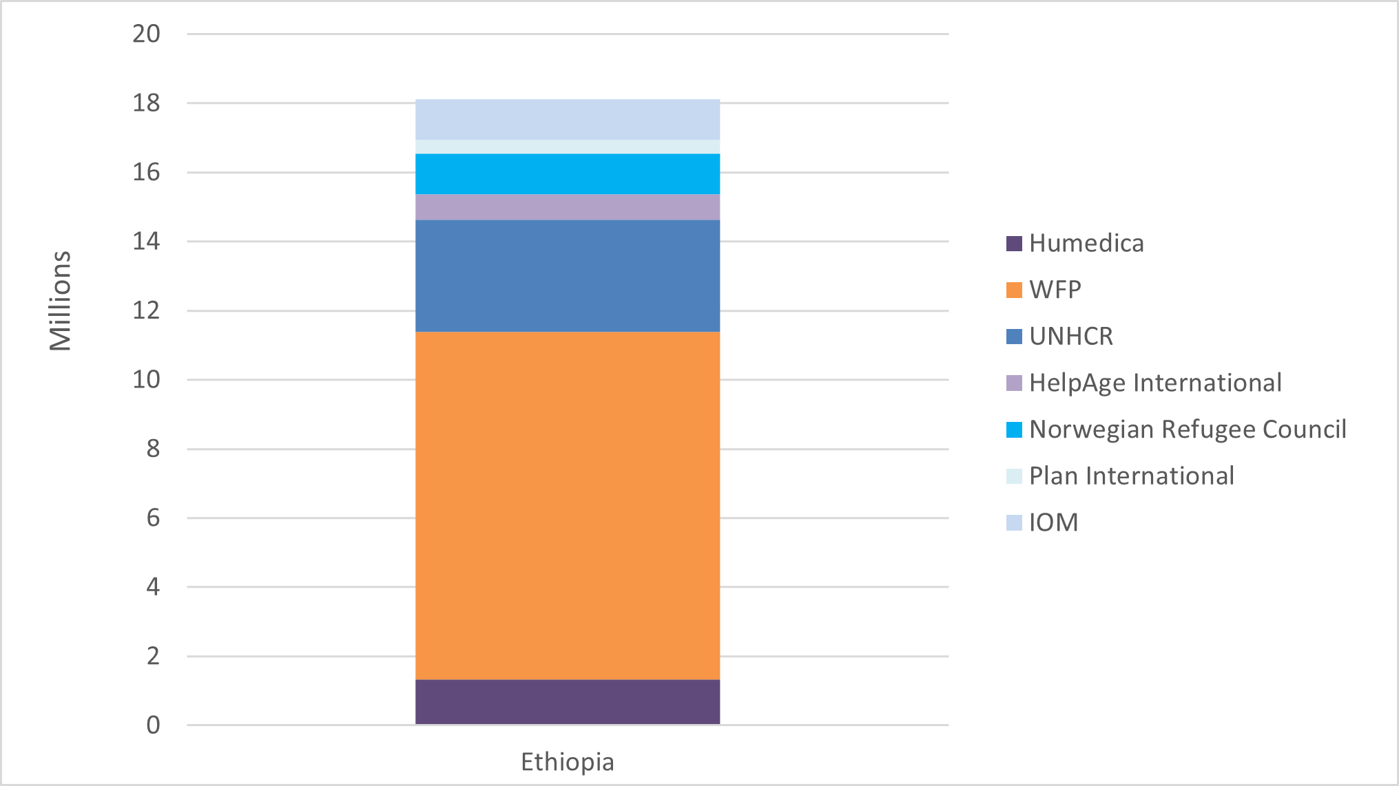
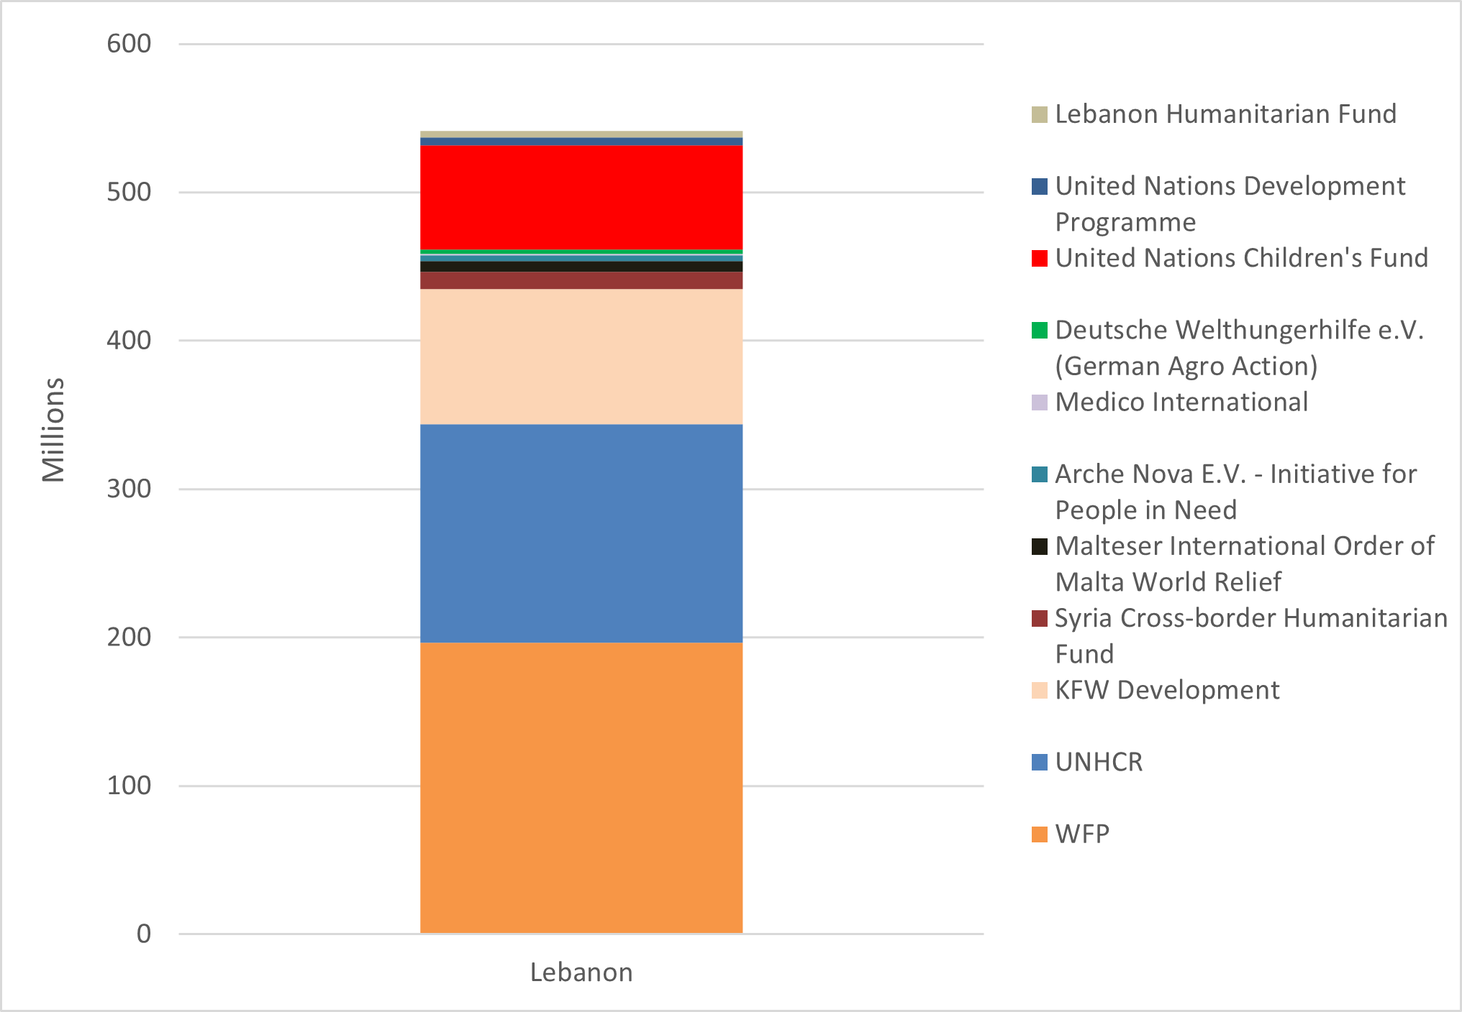
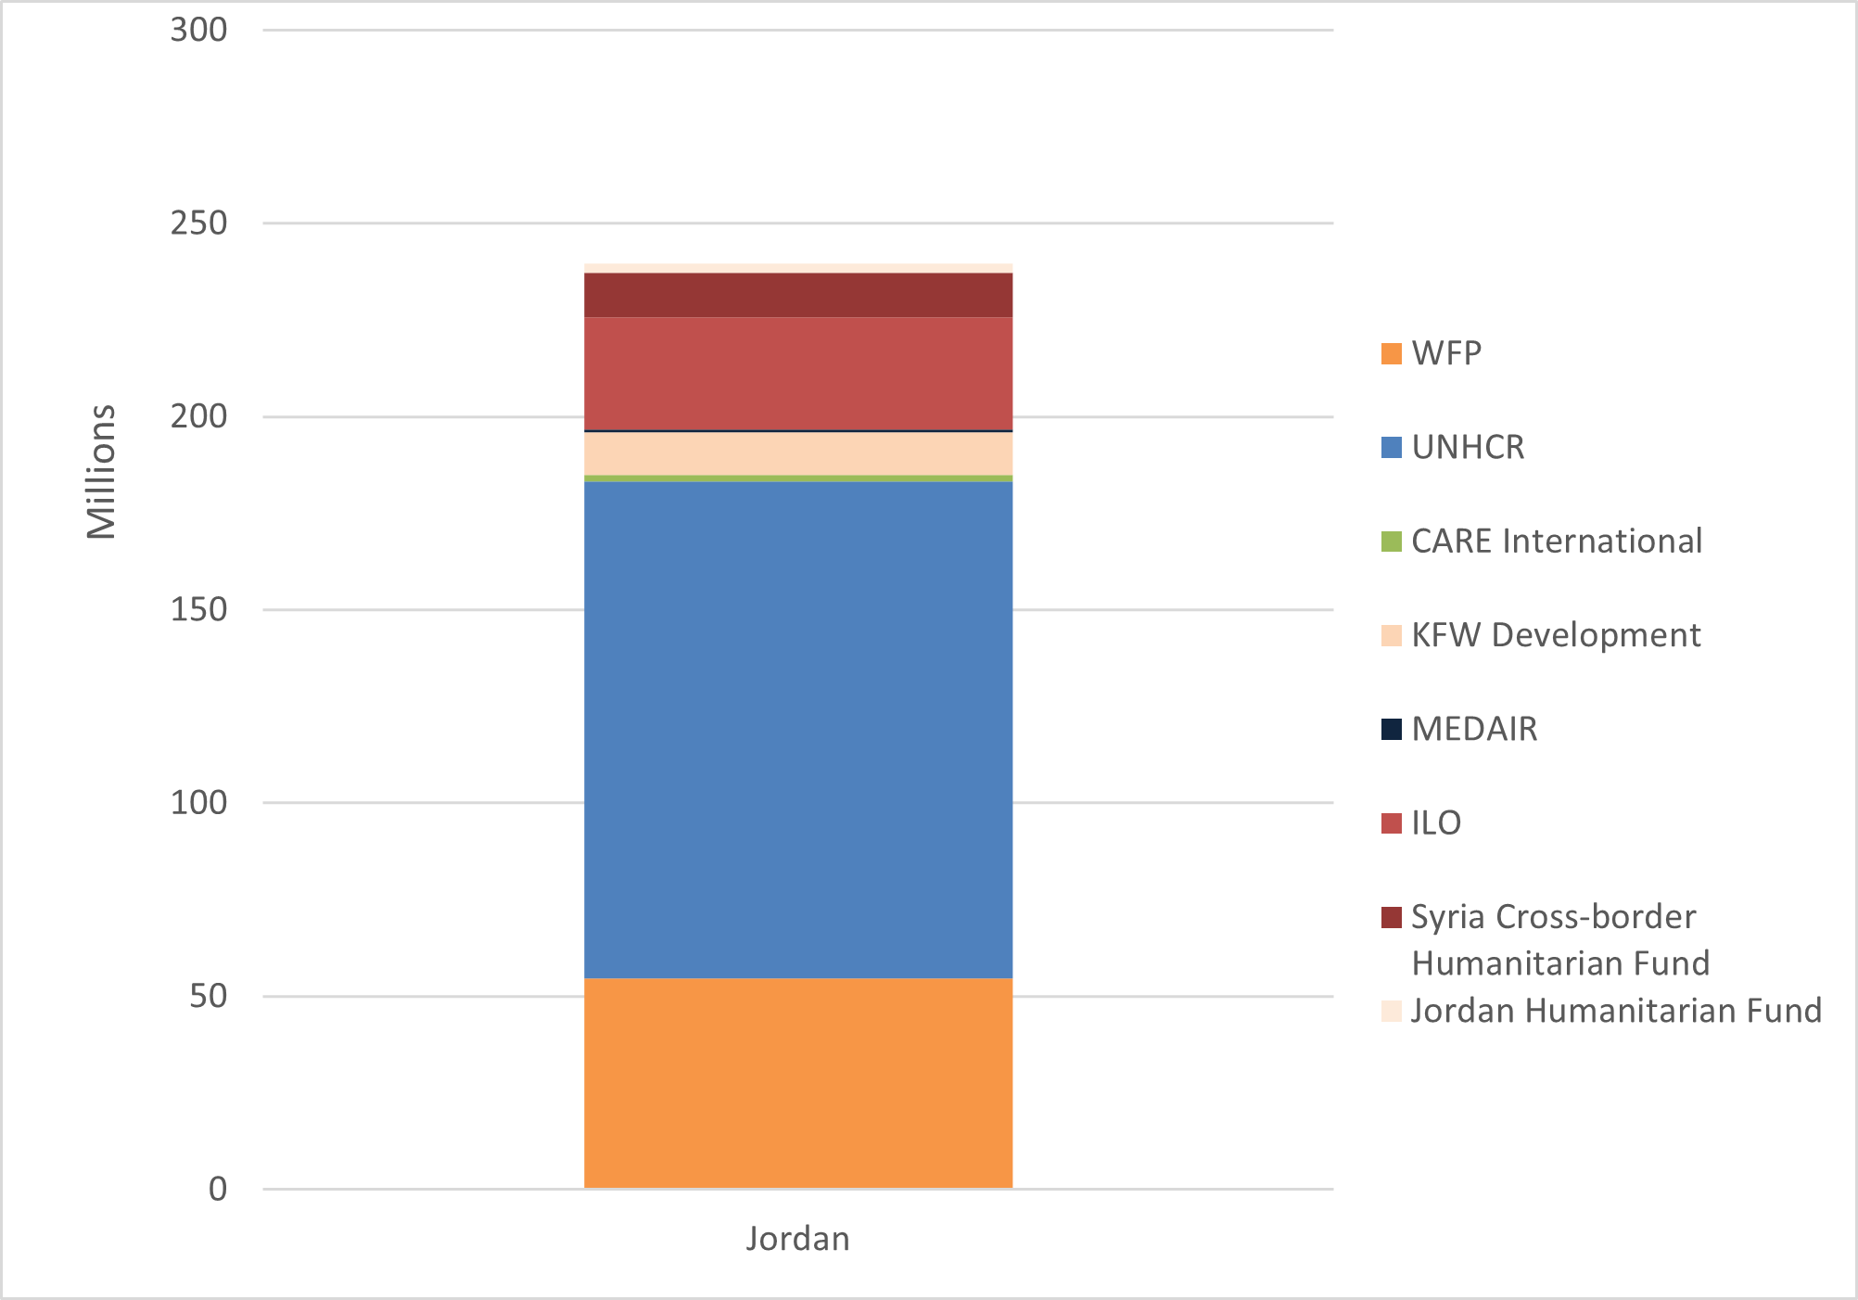
Source: OCHA Financial Tracking System, 2020

Tabel A5. Complete lijst van humanitaire hulp-bijdragen voor de bescherming van asielzoekers, vluchtelingen, IDPs 2020
Government of Denmark
Host country | Destination organization | Description | Amount (US$) | Funding status
Ethiopia | World Food Programme | Refugees | $3.017.950 | Paid Contribution
Ethiopia | World Food Programme | Refugees | $2.227.243 | Paid Contribution
Ethiopia | World Food Programme | Humanitarian assistance | $19.547 | Paid Contribution
Ethiopia | World Food Programme | Humanitarian assistance | $140.981 | Paid Contribution
Ethiopia | United Nations High Commissioner for Refugees | South Sudanese Refugees population - Country not determined | $9.571.491* | Paid Contribution
Ethiopia | United Nations Population Fund | Transformative Humanitarian Funding - GBV thematic area | $378.000 | Paid Contribution
 |  | Total amount for Ethiopia | $15.355.212**
Jordan | Danish Refugee Council | Hum. assistance Syrian refugees in Jordan | $316.028 | Commitment
Jordan | Danish Refugee Council | Hum. assistance to Syrian refugees in Jordan | $506.116 | Commitment
Jordan | CARITAS | Health Programme for Syrian Refugees and vulnerable Jordanians in Jordan | $1.685.836 | Commitment
 |  | Total amount for Jordan | $2.507.980
Lebanon | United Nations High Commissioner for Refugees | Lebanon Syria 3RP - GDNK02 - Lebanon - Dec18 | $1.516.799 | Paid Contribution
Lebanon | Danish Refugee Council | Protect, assist and advocate for refugees, internally displaced people, migrants and host communities particularly vulnerable to the pandemic. | $239.414 | Commitment
Lebanon | Danish Refugee Council | Hum. assistance Syrian refugees in Lebanon | $506.117 | Commitment
Lebanon | Lebanon Humanitarian Fund | Lebanon Humanitarian Fund (LHF) [OCT 7005] | $2.254.622 | Paid Contribution
 |  | Total amount for Lebanon | $4.516.952
Government of France
Host country | Destination organization | Description | Amount (US$) | Funding status
Jordan | World Food Programme | Jordan - 3RP | $113.122 | Paid Contribution
Jordan | World Food Programme | Assistance alimentaire d'urgence et nutrition: réfugiés syriens des camps d'Azraq et Zaatari ainsi que les populations hôtes | $452.489 | Paid Contribution
Jordan | United Nations Relief and Works Agency for Palestine Refugees in the Near East | Assistance alimentaire d'urgence. Cash assistance for food to Palestine Refugees from Syria (PRS) residing in Jordan (continuation of PQ19S12) | $545.852 | Paid Contribution
Jordan | United Nations High Commissioner for Refugees | Syria 3RP Energy and Environment | $534.111 | Paid Contribution
Jordan | United Nations High Commissioner for Refugees | Syria 3RP No Sector Earmarking | $1.741.202 | Paid Contribution
 |  | Total amount for Jordan | $3.386.776
Lebanon | World Food Programme | Assistance alimentaire d'urgence: réfugiés syriens et libanais vulnérables | $254.525 | Paid Contribution
Lebanon | United Nations Relief and Works Agency for Palestine Refugees in the Near East | Assistance alimentaire d'urgence: réfugiés palestiniens en situation de pauvreté absolue | $852.273 | Commitment
Lebanon | United Nations High Commissioner for Refugees | Syria 3RP No Sector Earmarking | $2.844.141 | Paid Contribution
Lebanon | World Food Programme | Assistance alimentaire d'urgence: réfugiés syriens et libanais vulnérables | $254.525 | Paid Contribution
Lebanon | French Red Cross | Soutien au renforcement des systèmes de santé et de quarantaine pour les populations réfugiées et hôtes vulnérables au Liban dans un contexte de covid-19 et de crise économique | $808.076 | Commitment
 |  | Total amount for Lebanon | $5.013.540
Government of Germany
Host country | Destination organization | Description | Amount (US$) | Funding status
Ethiopia | Humedica | Maintain basic medical care and strengthen health capacity in Dollo and Bokolomanyo districts refugee camps | $0 | Commitment
Ethiopia | Humedica | Maintain basic medical care and strengthen health capacity in Dollo and Bokolomanyo districts refugee camps | $1.322.066 | Commitment
Ethiopia | World Food Programme | Food aid for internally displaced persons and refugees in Ethiopia | $0 | Commitment
Ethiopia | World Food Programme | Food aid for internally displaced persons and refugees in Ethiopia (2020 portion) | $4.444.444 | Paid Contribution
Ethiopia | World Food Programme | Humanitarian assistance | $2.844.141 | Paid Contribution
Ethiopia | United Nations High Commissioner for Refugees | South Sudanese Refugees population - Country not determined | $3.240.486* | Paid Contribution
Ethiopia | HelpAge International | Integrated humanitarian Response | $153.409 | Paid Contribution
Ethiopia | HelpAge International | Improvement of nutrition, health and protection for particularly vulnerable internally displaced persons in the Oromia region | $0 | Commitment
Ethiopia | HelpAge International | Improvement of nutrition, health and protection for particularly vulnerable internally displaced persons in the Oromia region | $588.235 | Commitment
Ethiopia | Norwegian Refugee Council | Improved access to livelihoods and basic services for vulnerable populations affected by displacement in the Benishngul Gumuz region, Ethiopia | $0 | Commitment
Ethiopia | Norwegian Refugee Council | Improved access to livelihoods and basic services for vulnerable populations affected by displacement in the Benishngul Gumuz region, Ethiopia (2020 portion) | $1.176.471 | Commitment
Ethiopia | Plan International | Cross-country project to protect children and adolescents affected by the SSD crisis in Ethiopia, Sudan, South Sudan and Uganda | $0 | Commitment
Ethiopia | Plan International | Cross-country project to protect children and adolescents affected by the SSD crisis in Ethiopia, Sudan, South Sudan and Uganda (2020 portion) | $398.180 | Commitment
Ethiopia | World Food Programme | Food aid for internally displaced persons and refugees in Ethiopia (2020 portion) | $2.777.778 | Commitment
Ethiopia | International Organization for Migration | Emergency aid for internally displaced persons in Ethiopia | $0 | Commitment
Ethiopia | International Organization for Migration | Emergency aid for internally displaced persons in Ethiopia (2020 portion) | $1.175.088 | Commitment
 |  | Total amount for Ethiopia | $18.120.298**
Jordan | United Nations High Commissioner for Refugees | Support for Syrian IDPs and refugees | $0 | Commitment
Jordan | Malteser International Order of Malta World Relief | Emergency medical assistance for conflict-affected internally displaced persons and residents in the Turkish-Syrian border area | $0 | Commitment
Jordan | CARE International | Support and protective measures for crisis-affected Syrian refugees and Jordanians in five Jordanian cities | $0 | Commitment
Jordan | CARE International | Support and protective measures for crisis-affected Syrian refugees and Jordanians in five Jordanian cities. 2019: 1,500,000 €; 2020: 1,500,000 € (2020 portion) | $1.668.521 | Commitment
Jordan | KFW Development | UNICEF Macanic Centres in Jordan offer non-formal education, especially to Syrian refugee children, consisting of learning support, child protection measures with violence prevention, early childhood education, life skills and social education measures for young people. This benefits both children who are not enrolled in schools and children who are formally educated. The project also aims to improve access to educational and child protection measures for needy children and young people (BMZ 2019.1827.5) | $11.037.528 | Commitment
Jordan | United Nations High Commissioner for Refugees | Support for Syrian IDPs and refugees (2020 portion) for regional Syria 3RP of multyear 2017 - 2020 | $28.409.090* | Paid Contribution
Jordan | World Food Programme | Jordan - 3RP | $693.642 | Paid Contribution
Jordan | World Food Programme | Jordan - 3RP | $279.642 | Paid Contribution
Jordan | World Food Programme | Jordan - 3RP | $279.642 | Paid Contribution
Jordan | MEDAIR | Life-saving humanitarian assistance for refugees and vulnerable Jordanians in Jordan through community health and cash for health assistance | $0 | Commitment
Jordan | MEDAIR | Life-saving humanitarian assistance for refugees and vulnerable Jordanians in Jordan through community health and cash for health assistance | $577.440 | Commitment
Jordan | Jordan Humanitarian Fund | Jordan Humanitarian Fund (JHF) [OCT 7015] | $2.171.553 | Paid Contribution
Jordan | United Nations High Commissioner for Refugees | Against Other Operations in MENA linked to Syria 3RP | $25.563.891* | Paid Contribution
Jordan | International Labour Organization | Employment through Labour Intensive Infrastructure in Jordan - Phase V (BMZ) | $7.632.547 | Paid Contribution
Jordan | International Labour Organization | Employment through Labour Intensive Infrastructure in Jordan - Phase IV (BMZ) | $21.400.000 | Paid Contribution
Jordan | United Nations High Commissioner for Refugees | Against Other Operations in MENA linked to Syria 3RP | $27.225.544* | Paid Contribution
Jordan | United Nations High Commissioner for Refugees | Syria 3RP No Sector Earmarking | $5.455.506 | Paid Contribution
Jordan | United Nations High Commissioner for Refugees | Syria 3RP No Sector Earmarking | $8.351.315 | Paid Contribution
Jordan | United Nations High Commissioner for Refugees | Syria 3RP No Sector Earmarking | $33.684.428 | Paid Contribution
Jordan | World Food Programme | Food assistance and nutrition aid for vulnerable Syrian refugees in Jordan | $0 | Commitment
Jordan | World Food Programme | Food assistance and nutrition aid for vulnerable Syrian refugees in Jordan (2020 portion) | $53.317.536 | Paid Contribution
Jordan | Syria Cross-border Humanitarian Fund | Syria Cross-border Humanitarian Fund (SCHF) OCT 8410 | $11.750.881* | Commitment
 |  | Total amount for Jordan | $239.498.706**
Lebanon | United Nations High Commissioner for Refugees | Support for Syrian IDPs and refugees | $0 | Commitment
Lebanon | Malteser International Order of Malta World Relief | Contribution to an improved Resilienz of refugees and taking up municipalities in the district Baalbek, governorate Baalbek-Hermel (Lebanon) by strengthening of the Lebanese health system | $7.219.821* | Commitment
Lebanon | World Food Programme | Humanitarian Assistance to Syrian and Palestinian Refugees in Lebanon | $0 | Commitment
Lebanon | Arche Nova E.V. - Initiative for People in Need | Lebanese and Syrian families have equal access to safe drinking water and improved sanitation systems. This helps to prevent water-induced diseases and reduce social tension. | $3.688.525* | Commitment
Lebanon | World Food Programme | Humanitarian Assistance to Syrian and Palestinian Refugees in Lebanon (2020 portion) | $38.002.172 | Paid Contribution
Lebanon | KFW Development | The project objective is to improve access to high-quality services for Syrian and Palestinian refugees and the local population. The aim is to contribute to social stability in the host communities and to the promotion of the peace process. | $1.144.846* | Commitment
Lebanon | KFW Development | Improve the living conditions of the population affected by the ongoing crisis in and around Palestinian refugee camps in Lebanon. | $23.890.785* | Commitment
Lebanon | World Food Programme | Strategic Outcome 2 (SO2):Vulnerable women and Men in targeted refugee and Lebanese communities sustainably improve their skills, capacities and livelihood opportunities by 2020" (Resilience)Strategic Outcome 3 (SO3):" Vulnerable populations in Lebanon are enabled to meet their basic food needs al year long" (National Poverty Target Programme (NPTP)) | $120.022.753* | Commitment
Lebanon | Malteser International Order of Malta World Relief | Emergency medical assistance for conflict-affected internally displaced persons and residents in the Turkish-Syrian border area | $0 | Commitment
Lebanon | Deutsche Welthungerhilfe e.V. (German Agro Action) | Rural, Lebanese communities and Syrian refugees in Baalbek-Hermel have improved livelihoods and opportunities in the agricultural sector; social tensions are reduced. Multi year BMZ 2019 - 2022 | $1.993.435* | Commitment
Lebanon | World Food Programme | Humanitarian Assistance to Syrian and Palestinian Refugees in Lebanon (part of 2020 portion) | $11.376.564 | Paid Contribution
Lebanon | Medico International | Providing health services and training to Syrian refugees and vulnerable families in host communities (AA-S09 321.50 SYR 19/19) | $0 | Commitment
Lebanon | Medico International | Providing health services and training to Syrian refugees and vulnerable families in host communities | $1.127.569 | Commitment
Lebanon | Deutsche Welthungerhilfe e.V. (German Agro Action) | Rural, Lebanese communities and Syrian refugees in Baalbek-Hermel have improved livelihoods and opportunities in the agricultural sector; social tensions are reduced. Multi year BMZ 2019 - 2022 (2020 portion) | $683.807 | Commitment
Lebanon | World Food Programme | Humanitarian Assistance to Syrian and Palestinian Refugees in Lebanon (part of 2020 portion) | $16.592.920 | Paid Contribution
Lebanon | United Nations Children's Fund | Lebanon: Supp.the most vulnerable Lebanese and non-Lebanese households wiht impr. (SM180562) | $4.436.860 | Commitment
Lebanon | KFW Development | The aim is to make an important contribution to stabilising the host communities in Lebanon and to improve the resilience of the refugees and the local population (BMZ 2019.1851.5) | $0 | Commitment
Lebanon | KFW Development | The objective of the project is to improve the access of Lebanese and non-Lebanese children to formal education in the school year 2019/2020 and to contribute to the creation of an inclusive, child-friendly learning environment at public schools (BMZ 2019.1873.9) | $60.706.402 | Commitment
Lebanon | United Nations Development Programme | The aim is to make an important contribution to stabilising the host communities in Lebanon and to improve the resilience of the refugees and the local population (2020 portion) | $5.518.764 | Commitment
Lebanon | United Nations High Commissioner for Refugees | Support for Syrian IDPs and refugees (2020 portion) for regional Syria 3RP of multyear 2017 - 2020 | $28.409.090* | Paid Contribution
Lebanon | World Food Programme | Lebanon - 3RP | $1.184.834 | Paid Contribution
Lebanon | World Food Programme | Lebanon - 3RP | $1.184.834 | Paid Contribution
Lebanon | World Food Programme | Lebanon - 3RP | $1.210.176 | Paid Contribution
Lebanon | World Food Programme | Lebanon - 3RP | $1.734.104 | Paid Contribution
Lebanon | World Food Programme | Lebanon - 3RP | $2.516.779 | Paid Contribution
Lebanon | World Food Programme | Lebanon - 3RP | $2.516.779 | Paid Contribution
Lebanon | KFW Development | Support to refugees and short-term improvement and reconstruction of infrastructure in and around Palestinian refugee camps Lebanon 2020 (BMZ 2019.1826.7) | $5.428.882 | Commitment
Lebanon | KFW Development | Support to refugees and short-term improvement and reconstruction of infrastructure in and around Palestinian refugee camps Lebanon (BMZ 2019.1826.7) | $0 | Commitment
Lebanon | Lebanon Humanitarian Fund | Deposit into the Lebanon humanitarian Fund | $0 | Commitment
Lebanon | Lebanon Humanitarian Fund | Lebanon Humanitarian Fund (LHF) [OCT 7018] | $2.714.441 | Paid Contribution
Lebanon | United Nations High Commissioner for Refugees | Against Other Operations in MENA linked to Syria 3RP | $25.563.891* | Paid Contribution
Lebanon | Malteser International Order of Malta World Relief | Mobile health care for conflict-affected Syrian refugees and the receiving Lebanese communities in relation to the COVID-19 crisis | $113.636 | Commitment
Lebanon | United Nations High Commissioner for Refugees | Against Other Operations in MENA linked to Syria 3RP | $27.225.544* | Paid Contribution
Lebanon | United Nations High Commissioner for Refugees | Syria 3RP No Sector Earmarking | $19.000.982 | Paid Contribution
Lebanon | United Nations High Commissioner for Refugees | Syria 3RP No Sector Earmarking | $47.048.134 | Paid Contribution
Lebanon | Lebanon Humanitarian Fund | Distribution:Lebanon Humanitarian Fund (LHF) OCT 7079 | $1.764.706 | Commitment
Lebanon | Syria Cross-border Humanitarian Fund | Syria Cross-border Humanitarian Fund (SCHF) OCT 8410 | $11.750.881* | Commitment
Lebanon | United Nations Children's Fund | The aim of the project is to improve the access of Lebanese and non-Lebanese children to formal schooling in the school year 2020/2021 (access to education). In addition, the project contributes to the creation of an inclusive, child-friendly learning environment in public schools (quality of education). | $65.710.872* | Commitment
 |  | Total amount for Lebanon | $541.483.788**
Government of the Netherlands
Host country | Destination organization | Description | Amount (US$) | Funding status
Ethiopia | United Nations High Commissioner for Refugees | South Sudanese Refugees population - Country not determined | $3.240.486* | Paid Contribution
 |  | Total amount for Ethiopia | $3.240.486**
Jordan | International Labour Organization | PROSPECTS - Inclusive jobs and education for refugees and host communities in Jordan | $2.475.247 | Paid Contribution
Jordan | United Nations High Commissioner for Refugees | Syria 3RP Protection (GNLD11-Ref 4000003085-Nov19) | $2.511.495 | Paid Contribution
Jordan | United Nations High Commissioner for Refugees | Syria 3RP Undefined (GNLD11-Ref 4000003085-Nov19) | $105.500* | Paid Contribution
Jordan | United Nations High Commissioner for Refugees | Syria 3RP No Sector Earmarking (GNLD11-Ref 4000003085-Nov19) | $7.385* | Paid Contribution
 |  | Total amount for Jordan | $5.099.627**
Lebanon | United Nations High Commissioner for Refugees | Lebanon Syria 3RP - Shelter and NFIs | $2.940.880 | Paid Contribution
Lebanon | United Nations High Commissioner for Refugees | Lebanon Syria 3RP - Protection and Nutrition | $1.650.000 | Paid Contribution
Lebanon | United Nations High Commissioner for Refugees | Against Lebanon linked to Syria 3RP Protection | $900.000 | Paid Contribution
Lebanon | United Nations High Commissioner for Refugees | Syria 3RP Health & Nutrition | $750.000 | Paid Contribution
Lebanon | United Nations High Commissioner for Refugees | Against Syria 3RP - No Sector Earmarking | $321.362 | Paid Contribution
Lebanon | International Labour Organization | PROSPECTS - Inclusive jobs and education for refugees and host communities in Lebanon | $3.202.560 | Paid Contribution
Lebanon | United Nations High Commissioner for Refugees | Syria 3RP No Sector Earmarking | $20.000.000 | Paid Contribution
Lebanon | United Nations High Commissioner for Refugees | Syria 3RP No Sector Earmarking  (CD Description: GNLD11-Ref 4000003085-Nov19) | $8.000.000 | Paid Contribution
Lebanon | United Nations High Commissioner for Refugees | Syria 3RP Undefined (GNLD11-Ref 4000003085-Nov19) | $105.500* | Paid Contribution
Lebanon | United Nations High Commissioner for Refugees | Syria 3RP No Sector Earmarking (GNLD11-Ref 4000003085-Nov19) | $7.385* | Paid Contribution
 |  | Total amount for Lebanon | $37.877.687**
Government of Norway
Host country | Destination organization | Description | Amount (US$) | Funding status
Ethiopia | Ethiopia Humanitarian Fund | Ethiopia Humanitarian Fund [OCT 6935] (QZA-18/0177-25) | $473.126 | Paid Contribution
Ethiopia | Norwegian Refugee Council | Humanitarian Response in Ethiopia. (QZA-20/0048-5) | $1.726.765 | Paid Contribution
 |  | Total amount for Ethiopia | $2.199.891
Jordan | Norwegian Refugee Council | Humanitarian response in Jordan (QZA-20/0048-24) | $1.777.552 | Paid Contribution
Jordan | United Nations Relief and Works Agency for Palestine Refugees in the Near East | Jordan UNRWA - Support to Palestinian Refugees from Syria (PRS) 2020(MEU-20/0006-3) | $1.320.467 | Paid Contribution
Jordan | United Nations High Commissioner for Refugees | Activities in Jordan under the Regional Refugee and Resilience Plan (3RP) Gender is a strategic element in the program, based on a gender analysis. (QZA-18/0302-5) | $2.640.934 | Paid Contribution
 |  | Total amount for Jordan | $5.738.953
Lebanon | Save the Children | Ensuring Education and Protection for Syrian Refugee Children in Lebanon. Protection of children, education in emergencies. (QZA-20/0058-3) | $465.490 | Paid Contribution
Lebanon | Norwegian Refugee Council | Humanitarian response in Lebanon (QZA-20/0048-25) | $2.539.360 | Paid Contribution
Lebanon | Norwegian Red Cross | Humanitarian activities in Lebanon (QZA-20/0075-9) | $812.595 | Paid Contribution
Lebanon | United Nations Relief and Works Agency for Palestine Refugees in the Near East | Lebanon UNRWA - Support to Palestinian Refugees from Syria (PRS) 2020(MEU-20/0006-2) | $3.047.232 | Paid Contribution
Lebanon | United Nations High Commissioner for Refugees | Activities in Lebanon under the Regional Refugee and Resilience Plan (3RP) Gender is a strategic element in the program, based on a gender analysis. (QZA-18/0302-4) | $5.638.192 | Paid Contribution
Lebanon | Heartland Alliance International | The project seeks to enhance the safety and wellbeing of Syrian refugee women and girls accessing targeted primary health care centers, and empower them to make informed decisions about their sexual and reproductive health. (LBN-18/0006) | $242.879 | Paid Contribution
Lebanon | The National Institution of Social Care and Vocational Training | The project aims at improving reproductive health of vulnerable women through access to clinics and improving psychological wellbeing of marginalized young girld and boys through music and sports activities in Palestinian camps. (LBN-19/0005) | $159.117 | Paid Contribution
Lebanon | United Nations Relief and Works Agency for Palestine Refugees in the Near East | Safety and Security | $23.144 | Commitment
 |  | Total amount for Lebanon | $12.928.009
Government of United Kingdom
Host country | Destination organization | Description | Amount (US$) | Funding status
Ethiopia | United Nations High Commissioner for Refugees | United Nations High Commissioner for Refugees (UNHCR) Support to Refugees and Migration in Ethiopia | $3.861.004 | Paid Contribution
Ethiopia | United Nations Children's Fund | United Nations Children’s Fund (UNICEF) Support to Refugees and Migration programme in Ethiopia | $12.870.013 | Paid Contribution
Ethiopia | NGOs (details not yet provided) | Support to Refugees and Migration in Ethiopia | $4.521.426 | Paid Contribution
Ethiopia | World Bank | Support the refugee related response | $4.819.510 | Paid Contribution
Ethiopia | Ethiopia, Government of | Emergency Humanitarian Support | $26.420.079 | Commitment
Ethiopia | World Food Programme | Support to Refugees and Migration in Ethiopia | $6.490.304 | Paid Contribution
 |  | Total amount for Ethiopia | $58.982.336
Jordan | International Medical Corps | Specialised Protection Intervention for Vulnerable Refugees and Host Communities in Jordan | $2.840.780 | Commitment
Jordan | United Nations High Commissioner for Refugees | Jordan Syria 3RP - with portio nof Shelter NFIs' response | $11.585.366 | Paid Contribution
Jordan | World Food Programme | Jordan - 3RP | $12.289.780 | Paid Contribution
Jordan | Jordan Humanitarian Fund | Jordan Humanitarian Fund (JHF) [OCT 6956] | $2.484.472 | Paid Contribution
Jordan | Handicap International / Humanity & Inclusion | Safety and dignity for Syrian refugees and vulnerable Jordanians with disabilities | $298.903 | Paid Contribution
Jordan | United Nations High Commissioner for Refugees | Delivering cash assistance to refugees | $9.500.000 | Commitment
 |  | Total amount for Jordan | $38.999.301
Lebanon | World Food Programme | Lebanon - 3RP | $24.660.912 | Paid Contribution
 |  | Total amount for Lebanon | $24.660.912

*This amount is allocated to more than one country and cannot be disaggregated.
**This amount includes funds that have been allocated to more than one country and cannot be disaggregated.

UNHCR A Comprehensive Refugee Response Framework for Central Africa, https://www.unhcr.org/59032f154.pdf [2021, december].
Papadopoulou, A. 2015. Regional Protection Programmes: an effective policy tool? DOMAID Discussion Paper. Brussels: ECRE.
Europese Commissie (2011) “Communication from the Commission to the European Parliament, the Council, the European Economic and Social Committee and the Committee of the Regions”, Brussel. [Online]. Beschikbaar: https://eur-lex.europa.eu/legal-content/EN/TXT/PDF/?uri=CELEX:52011DC0743&from=EN [2020, december].
RDPP Lebanon, Jordan, Iraq (2019-2021) “Regional Development and Protection Programme in the Middle East (RDPP II)” [Online]. Beschikbaar: http://rdpp-me.org/RDPPfiles/files/Programme-Document.pdf [2020, december].
RDPP Lebanon, Jordan, Iraq (2018-2019) “Annual Report Year 1” [Online]. Beschikbaar: http://www.3rpsyriacrisis.org/wp-content/uploads/2020/04/rso_150dpi.pdf [2020, december].
OCHA Syria Refugee Response and Resilience Plan (3RP) 2020, https://fts.unocha.org/appeals/943/flows?f%5B0%5D=sourceOrganizationIdName%3A3776%3ADenmark%2C%20Government%20of&f%5B1%5D=sourceOrganizationIdName%3A4314%3AFrance%2C%20Government%20of&f%5B2%5D=sourceOrganizationIdName%3A4306%3AGermany%2C%20Government%20of&f%5B3%5D=sourceOrganizationIdName%3A2917%3AUnited%20Kingdom%2C%20Government%20of&order=flow_property_directional&sort=asc&page=2#search-results [2020, december].
Federale ministerie voor Economische Samenwerking en Ontwikkeling (2019) “Partnerships for Prospects” [Online]. Beschikbaar: https://www.bmz.de/en/publications/type_of_publication/information_flyer/information_brochures/Materialie272_cash_for_work.pdf [2020, december].
Government of Jordan (2020) “Jordan Response Plan for the Syria Crisis 2020-2022” [Online]. Beschikbaar: https://reliefweb.int/sites/reliefweb.int/files/resources/77262.pdf [2020, december].
The Embassy of the Hashemite Kingdom of Jordan Washington D.C. “Jordan Response Plan funding stands at $644m — Planning Ministry”, 28 september 2020 [Online]. Beschikbaar: http://jordanembassyus.org/news/jordan-response-plan-funding-stands-644m-planning-ministry [2020, december].
Government of Lebanon and the United Nations (2020) “Lebanon Crisis Response Plan 2017-2020” [Online]. Beschikbaar: https://reliefweb.int/sites/reliefweb.int/files/resources/74641.pdf [2020, december].
KfW Unterstütz. v. Flüchtlingen sowie kurzfrist. Verbesserung u. Wiederaufbau v. Infrastruktur in u. um paläst. Flüchtlings.https://www.kfw-entwicklungsbank.de/ipfz/Projektdatenbank/Unterstütz-v-Flüchtlingen-sowie-kurzfrist-Verbesserung-u-Wiederaufbau-v-Infrastruktur-in-u-um-paläst-Flüchtlings-38863.htm, [2020, december].
KfW Libanon – UNWRA Beschäftigungsförderung palästinensischer Flüchtlinge in Libanon”(Phase III) https://www.kfw-entwicklungsbank.de/ipfz/Projektdatenbank/Libanon---UNRWA-Besch%C3%A4ftigungsf%C3%B6rderung-pal%C3%A4stinensischer-Fl%C3%BCchtlinge-im-Libanon-Phase-III-42027.htm, [2020, december].
KfW UNRWA Libanon, Finanzierung von Nothilfemassnahmen für syrische-palästin. Flüchtlinge u. aufnehmende Kommunen https://www.kfw-entwicklungsbank.de/ipfz/Projektdatenbank/UNRWA-Libanon-Finanzierung-von-Nothilfema%C3%9Fnahmen-f%C3%BCr-syrische-pal%C3%A4stin-Fl%C3%BCchtlinge-u-aufnehmende-Kommunen-41629.htm, [2020, december].
KfW Verbesserung der Lebensbedingungen – UNDP Lebanon Host Communities Support Programme, Phase 2 https://www.kfw-entwicklungsbank.de/ipfz/Projektdatenbank/Verbesserung-der-Lebensbedingungen---UNDP-Lebanon-Host-Communities-Support-Programme-Phase-2-40748.htm, [2020, december].
EU Emergency Trust Fund for Africa (2021) “Better Migration Management (Karthoum Process)” [Online]. Beschikbaar: https://ec.europa.eu/trustfundforafrica/sites/euetfa/files/rider_t05-eutf-hoa-reg-09_-_better_migration_management.pdf [2020, december].
EU Emergency Trust Fund for Africa (2021) “Delivering durable solutionsto forced displacement in the IGAD region through the implementation of the global compact on refugees (GCR)” [Online]. Beschikbaar: https://ec.europa.eu/trustfundforafrica/region/horn-africa/regional/delivering-durable-solutions-forced-displacement-igad-region-through_en [2020, december].
EU Emergency Trust Fund for Africa “Regional Development and Protection Programme in Ethiopia” [Online]. Beschikbaar: https://ec.europa.eu/trustfundforafrica/region/horn-africa/ethiopia/regional-development-and-protection-programme-ethiopia_en [2020, december].
Karthoum Process Regional Development Protection Programme (RDPP) – Horn of Africa https://www.khartoumprocess.net/operations/31-regional-development-protection-programme-rdpp-horn-of-africa [2020, december].
Abebe (2018) “Ethiopia’s refugee response” [Online]. Beschikbaar: https://media.africaportal.org/documents/Ethiopias_refugee_response.pdf [2020, december].
UNHCR (2018) “CRRF Ethiopia” [Online]. Beschikbaar: https://data2.unhcr.org/en/documents/download/65916 [2020, december].
UNHCR (2020) “Ethiopia Country Refugee Response Plan 2020-2021” [Online]. Beschikbaar: https://reporting.unhcr.org/sites/default/files/Ethiopia%202020-2021%20Country%20Refugee%20Response%20Plan%20-%20January%202020.pdf [2020, december].
UNHCR Ethiopia Country Refugee Response Plan 2019-2020 – Inter-Agency Mid-Year Financial Update https://data2.unhcr.org/en/documents/details/70940 [2020, december].
Deutsche Gesellschaft fürIn Kooperation mitÄthiopisches Ministerum für Wissenschaftund HöhereInternationale Zusammenarbeit (2020) “Qualifizierung und Beschäftigungsperspekti-ven für Flüchtlinge und aufnehmende Bevölke-rungin Äthiopien (QEP)” https://www.giz.de/de/downloads/giz2020_de_Factsheet_revised%20incl_Output%204.pdf [2020, december].
World Bank data, GDP, PPP (current international $), [Online]. Beschikbaar: https://data.worldbank.org/indicator/NY.GDP.MKTP.PP.CD?end=2019&locations=GY-DK-FR&start=1990&view=chart [2020, december].
Data voor elk begunstigd land is beschikbaar via https://fts.unocha.org/.

