Dr. Subrahmanyam JaishankarDr. S Jaishankar, External Affairs Minister.
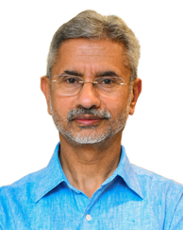

Earlier Dr S Jaishankar was President – Global Corporate Affairs at Tata Sons Private Limited from May 2018.
He was Foreign Secretary from 2015-18, Ambassador to United States from 2013-15, Ambassador to China from 2009-2013, High Commissioner to Singapore from 2007-2009 and Ambassador to the Czech Republic from 2000-2004.

He has also served in other diplomatic assignments in Embassies in Moscow, Colombo, Budapest and Tokyo, as well in the Ministry of External Affairs and the President’s Secretariat.

Dr S. Jaishankar is a graduate of St. Stephen’s College at the University of Delhi. He has an MA in Political Science and an M. Phil and Ph.D in International Relations from Jawaharlal Nehru University, Delhi.

He is a recipient of the Padma Shri award in 2019.

He is married to Kyoko Jaishankar and has two sons & and a daughter.

