Hisham Ibrahim Marwah
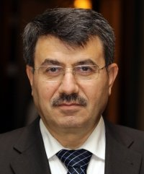
- Current Position:Vice Presidents
- From:Jan 05, 2015
- Political :Syrian National Council
- City:Damascus Suburb
- Date of Birth:Monday, 01 January 1962
- Place of Birth:Damascus Suburb
- Educational attainment:PhD in Law
- Sex:Male
- Additional Information:Legal Consultant
Born in Qatana in 1962, Hisham Marwah was elected as the Vice President of the National Coalition of Syrian Revolution and Opposition Forces on January 5, 2015. Marwah has been an active member of the Syrian opposition since the early 70’s. With a PhD in Comparative Law, Marwah practiced law since 1993. He is the author of books and articles on various legal issues, including the intersection of Islamic law with modern society, financial markets, and corporate corruption, as well as various studies on establishing democracy and a thriving civil state in the Muslim world.
Marwah is a founding member of the Syrian National Council and the Syrian Coalition, serving on the their legal committees and participating in the construction of their constitutions.
With a passion for transitional justice, Marwah participated in many conferences in this field and works tirelessly to ensure that Syrians are prepared with a transitional justice plan that protects minorities and ensures human and civil rights for all Syrians.
Marwah believes in the fastest route to a peaceful resolution to the Syrian crisis, the main goals being ending the bloodshed and transiting into a free and democratic state. As a lawyer and as the Vice President of the Syrian Coalition, Marwah views his role as representing, advocating for and protecting the founding principles of the Syrian revolution at international platforms and in political negotiations.

