MR. PAVLO KLIMKIN – DEPUTY MINISTER FOR FOREIGN AFFAIRS OF UKRAINE

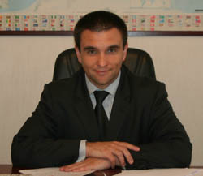
  Date and place of birth: 25 December 1967, Kursk
  Higher education: in 1991 graduated from the Moscow Institute of Physics and Technology, department of Aerophysics and Space Research, master's degree in physics and mathematics

Professional activity:

1991-1993 – research officer, National Academy of Science of Ukraine, Paton Welding Institute

1993-1997 - Attache, Third, Second Secretary of the Directorate General for Arms Control and Disarmament, the MFA

1997-2000 - Second Secretary for political issues of the Embassy of Ukraine to the Federal Republic of Germany (political, scientific and technical issues)

2000-2002 – First Secretary, Counselor of the Department for economic cooperation, the MFA (nuclear and energy security)

2002-2004 – Head of division for economic and sectoral cooperation with the EU of the Department for European integration, the MFA

2004-2008 – Minister-Counselor, Deputy Head of Mission, Embassy of Ukraine to the Great Britain

03.2008-04.2010 – Director of the EU Department, the MFA

21.04.2010 - present time – Deputy Minister for Foreign Affairs of Ukraine (Decree of the Cabinet of Ministers of Ukraine № 950)

22.12. 2010 - Diplomatic Rank of the Ambassador Extraordinary and Plenipotentiary

Fluent in English and German languages
Married, has two sons

