John RWANGOMBWA (Rwanda)
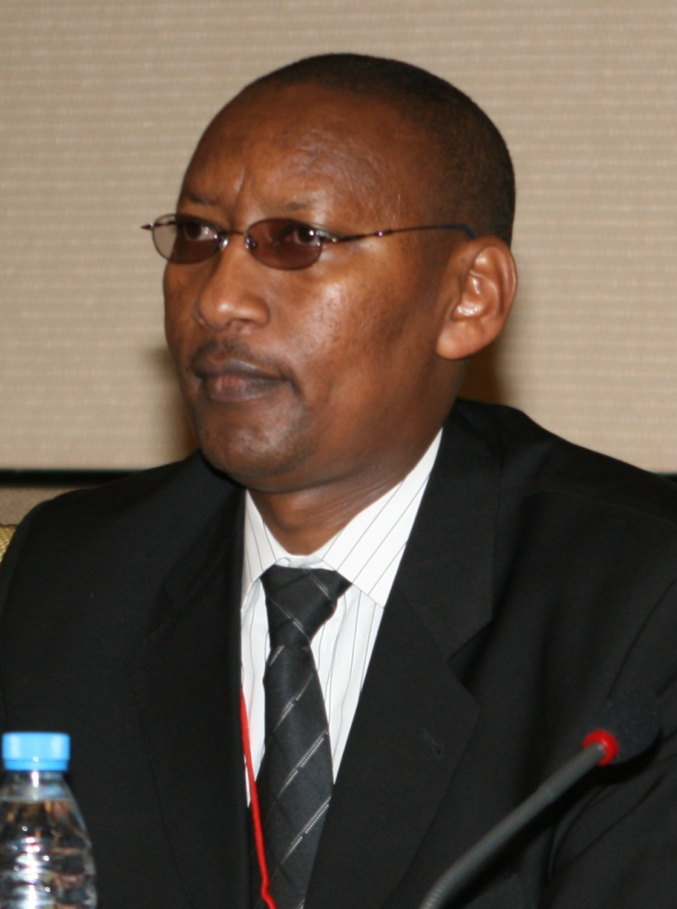

The Minister of Finance and Economic Planning. Hon. John Rwangombwa was appointed to cabinet in December 2009.

Prior to this appointment, Hon. John served as the Permanent Secretary and Secretary to Treasury «PS/ST » in the Ministry of Finance and Economic Planning since September 2005.

Before his appointment as PS/ST Hon. John Rwangombwa served in various departments as the Accountant General, and Director of the National Treasury in the same Ministry for one and five years respectively, where he helped the set up of the Accountant General’s Office and oversaw the implementation of several reforms related to Public Financial Management (PFM). He had also served as the Deputy Director of Customs in Rwanda Revenue Authority since 1994.

Hon. Rwangombwa has an educational background in Accounting and holds a Masters degree from the Maastricht School of Management, Netherlands.

He has been the chair of several Board of Directors among which: School of Finance and Banking, Vice Chairman Rwanda Revenue Authority, Vice Chairman of BRALIRWA S.A., Director of East African Development Bank, among others.

He has also been the chair of the Development Partners Consultative Group which gathers all development partners involved in Rwanda and high level government official to ensure coordination of aid financed development activities. He is actively involved in international events related to international development issues.

