PARLIAMENT OF FINLAND
Delegation of the Social Affairs and Health Committee

The Hague and Brussels 21.4. – 24.4.2009

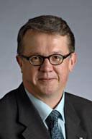
Me Juha Rehula
Chairperson of the Committee

B.A. (Soc. Sci.)

Resident in Hollola
Member of Parliament since 1996
Finnish Centre Party

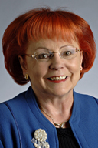
Ms Sirpa Asko-Seljavaara
Vice Chair

Doctor of Medicine and Surgery

Resident in Espoo
Member of Parliament since 1999
National Coalition Party

Mr Risto Autio

Master of Science (the Theatre)

Resident in Hausjärvi
Member of Parliament since 2007
Finnish Centre Party

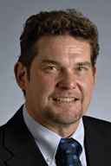

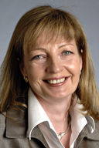

Ms Anneli Kiljunen

Diploma in Social Welfare

Resident in Lappeenranta
Member of Parliament since 2003
Social Democratic Party

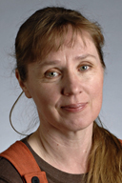
Ms Marjaana Koskinen

Social Worker

Resident in Raisio
Member of Parliament since 1999
Social Democratic Party

Mr Jukka Mäkelä

Master of Science in Technology

Resident in Espoo
Member of Parliament since 2007
National Coalition Party

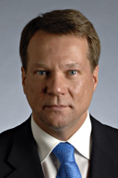

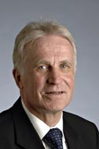
Mr Håkan Nordman

Master of Social Sciences

Resident in Vaasa
Member of Parliament since 1983-1995, 1999-2003, 2007
Swedish People's Party

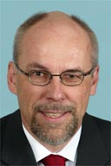
Mr Erkki Virtanen

Managing Director

Resident in Kuopio
Member of Parliament since 2003
Left Alliance

Civil servants

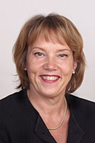
Ms Eila Mäkipää
Committee Counsel

Master of Laws (LL.M),

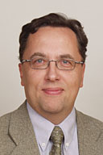
Mr Harri Sintonen
Committee Counsel

Master of Laws (LL.M),

