 | 
COUNCIL OF  THE EUROPEAN UNION |  |  | Brussels, 15 December 2008
 |  |  | 17160/08
 |  |  | EUROPOL 83

NOTE
from: | Europol
to: | Article 36 Committee
Subject : | Audit report and discharge for the period of 1 January 2007 - 31 December 2007

- Article 36, paragraphs 3 and 5 of the Europol Convention reads:

"(3) The joint audit committee shall in accordance with the procedure laid down in Title VI of the Treaty on European Union submit to the Council an audit report on the annual accounts; prior thereto the Director and Financial Controller shall be given an opportunity to express an opinion on the audit report and the report shall be discussed by the Management Board.

- A decision on the discharge to be given to the Director in respect of budget implementation for the financial year in question shall be taken by the Council, after examination of the report on the annual accounts."

2. In Annex please find a letter of the Chairman of the Europol Management Board to the Secretary-general of the Council of the European Union (annex 1) together with the audit report for the period 1 January 2007 – 31 December 2007 as drawn up by the Joint Audit Committee of Europol and discussed by the Management Board (annex 2).

3. On the basis of the Audit Report the Management Board decided to recommend to the Council to give discharge to the Director of Europol for the implementation of the 2007 budget.

4. On this basis, the Article 36 Committee is requested to invite COREPER/Council to examine the Audit Report and to give discharge to the Director of Europol in respect to the implementation of the budget for the period 1 January 2007 – 31 December 2007.

________________________

ANNEX 1

EUROPOL  Management Board | The Hague, 5 December 2008  File nº MBS 186.2008

Mr Javier Solana
Secretary-General
Council of the European Union
Brussels

Dear Secretary General,

The Management Board meeting held on 3-4 December 2008 considered the question of discharge to the Europol Director for the implementation of the 2007 budget, in accordance with Article 55(2) of the Financial Regulation and taking into account the advice of the Financial Committee meeting on 10 November 2008.

The basis for the discussions included the annual accounts as presented by Europol, the audit report from the Joint Audit Committee (JAC) and the opinions of the Financial Controller and of Europol on the audit report.

The JAC was of the opinion that the financial statements of Europol fairly presented the financial position as at 31 December 2007.

The JAC also made the following observations/recommendations:

- Budget implementation and treasury management – The underspending of the budget and large cash balances on Europol’s bank accounts suggest that there is still room for improvement in the area of budgetary planning and accuracy.

- Procurement procedures – Need to be carefully monitored in order to ensure a sufficiently rigorous application.
- Effectiveness of information systems – The JAC draws attention to the responsibility of the Member States to provide both the Europol Information System (EIS) and the overall analysis system for intelligence and support (OASIS) with information in accordance with the Convention. It also observes, for both EIS and OASIS, that there are no performance indicators to assess the impact or effectiveness of the systems.
- The establishment of Europol as a European Agency:
  - Accrual-based accounting - The JAC is of the opinion that although Europol is exercising proper risk management, there is still a risk that it may not have the capacity required for a timely implementation of accrual-based accounting. The full support of the European Commission is a prerequisite to avoid such a situation.
  - Staff turnover – While there is not yet a clear upward trend in the number of resignations, the JAC recognises an inherent risk of higher staff turnover in the coming period.
  - Financial Controller’s function – The JAC welcomes Europol’s intention to ensure a smooth transformation of the Financial Controller’s function into an internal audit function from 2010.
  - New Headquarters – Due to the delay in Europol’s planned move to its new headquarters, a budgetary impact in 2010 (when Europol will already have agency status and will be financed from the Community budget) is expected.
  - Unemployment fund – Although it is unlikely to occur, the most pessimistic scenario is that Europol could exhaust the funds available in its unemployment fund. The JAC therefore recommends more frequent assessments on the assets held by the fund.

The JAC also stressed the following observations/recommendations made in 2006:

- Contract database – Due to the inherent vulnerability of a spreadsheet-based database, the JAC recommends that a more sustainable solution be put in place as soon as possible.

- Business continuity – A business continuity plan and disaster recovery plan should be developed.
- National pension rights – There is a lack of adequate justification for delaying requests from staff to transfer pension rights acquired under national pension schemes.
- Legal claim against former employee – Although it is unlikely that any more of the outstanding claim will be recovered, there has been some development concerning information on the former employee’s bank accounts and Europol continues to investigate this matter.

Considering the comments provided by the Financial Controller and Europol, the Financial Committee came to the conclusion that discharge should be given to the Europol Director.

After taking careful note of the observations made by the JAC and the conclusions from the Financial Committee, the Management Board decided to recommend to the Council to give discharge to the Europol Director for the implementation of the 2007 budget.

Yours sincerely,

Bernard Petit
Chairman of the Management Board

ANNEX 2
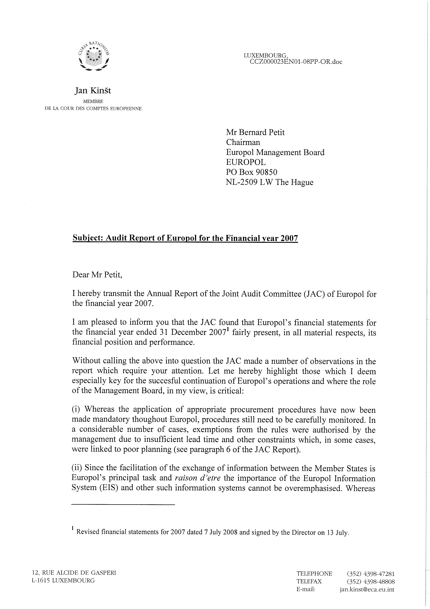

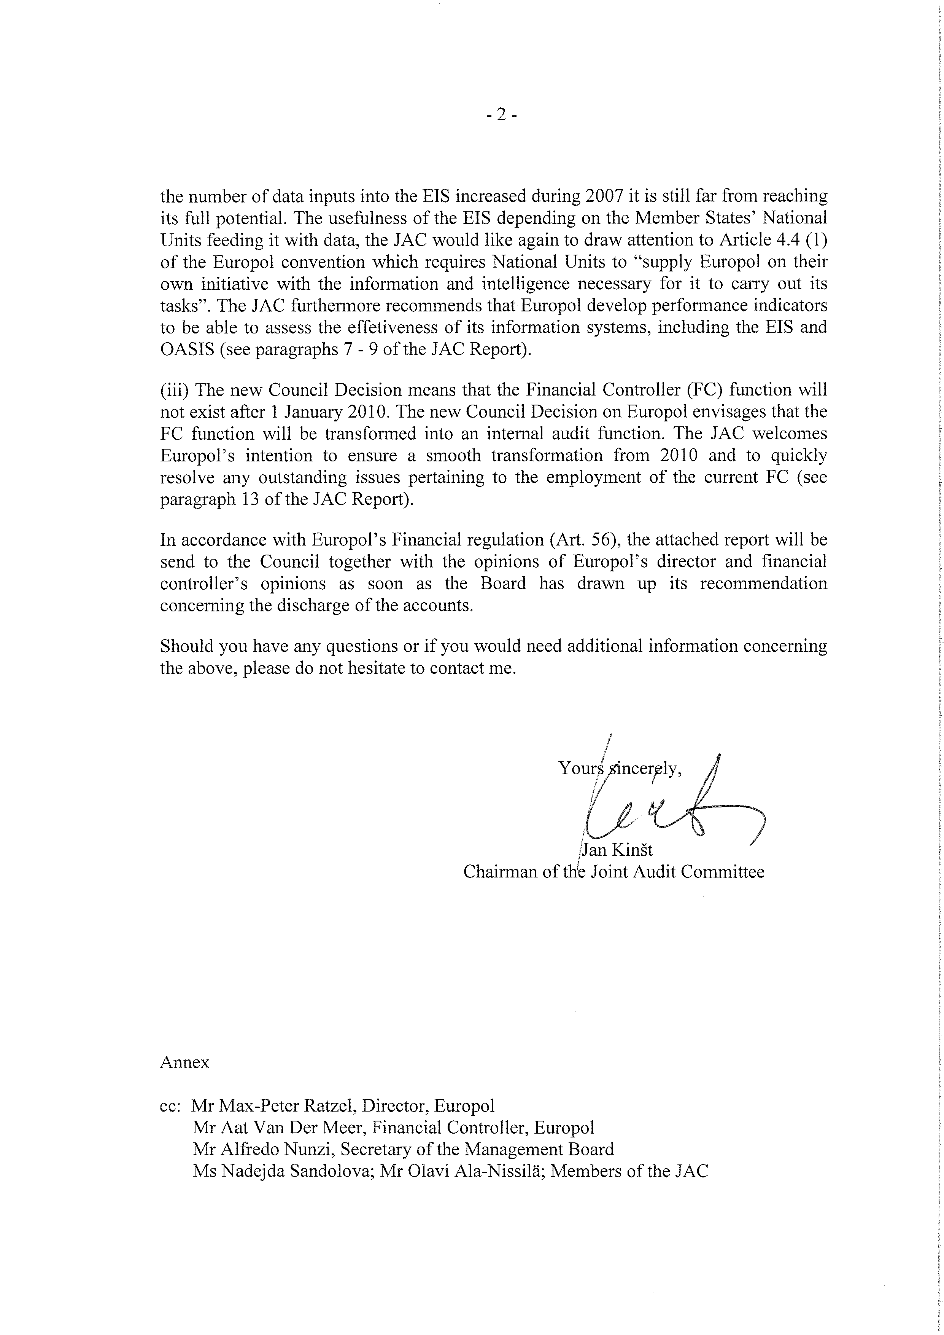

ANNEX 3
