1st Deputy Minister ( the European Union, security policy, bilateral relations with European countries)
12.10.2005 13:10
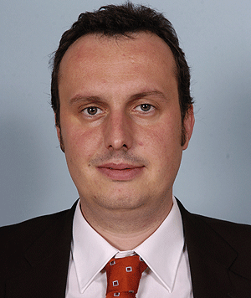
Name: Tomáš POJAR
Date of birth:
December 28, 1973
Politics:
Member of The Civic Democratic Party (ODS)
Education:
Charles University, Faculty of Social Sciences, specialization - politology
Study stays and training abroad:
1990-1992 American International School in Israel, Tel Aviv
2003-2004 Reagan-Fascell Democracy Fellowship / National Endowment for Democracy, Washington D.C.
Work experience:
1995
People in Need Foundation, coordinator of programmes in the territory of the former Soviet Union
1996-1997
Civilian service
1997-2005
Director of the People in Need - Czech Television Foundation
July 2005 - October 11, 2005
Adviser to the Deputy Minister of Foreign Affairs of the Czech Republic for Bilateral Relations
October 12, 2005 - September 2006
Deputy Minister of Foreign Affairs of the Czech Republic for Bilateral Relations
Since September 2006
1st Deputy Minister of Foreign Affairs
Marital status:
Married, name of spouse Martina, names of children Eduard, Rachel, Eliáš
Hobbies:
Pipe, good wine, literature, international politics

